DESIGNING OF ADAPTIVE MULTIFUNCTIONAL
MEN'S UNDERWEAR

Hlushko Yuliia, Bukhantsova Lіudmyla, Luschevska Оlena, Troian Oleksandr, Krasniuk Larysa, Yantsalovskyi Oleksandr
Khmelnitsky National University, Institytska str. 11, Khmelnitsky, UKRAINE,
e-mail: milabunyak@i.ua

Abstract: The object of research is the process of designing of adaptive multifunctional clothing. The basis for improvement of designing of adaptive multifunctional clothing is the application of energy-information effects of materials on the functional state of the human body. On the basis of this, it is justified to form a package of materials for development of adaptive men's underwear for treatment and prevention of chronic prostatitis. A positive therapeutic and prophylactic effect on patients is ensured by silver plates located on adaptive multifunctional underwear sites according to the biologically active zones of the lower part of the men’s body. Provision of multifunctional clothing with advanced functionality has a positive economic effect by reducing the consumer's money costs and reducing the time spent on medical procedures. The social effect of the work is manifested in improving the health status of men with chronic prostatitis, and, accordingly, improving the quality of their life. The effectiveness of the developed adaptive multifunctional underwear is confirmed by experimental wearing and clinical approbation.
Keywords: adaptive multifunctional underwear, energy-information impact, energy lability.

INTRODUCTION

The desing of multifunctional clothing is the process of harmonizing the «man – clothing – environment» system on the basis of providing the product with additional functional capabilities aimed at improving the life quality of a modern person.
Multifunctional clothing is a product or a set of products, which has a wider application for the user due to a combination of basic and additional functions that expand its purpose [2].
Multifunctional clothing promotes human adaptation to changing environmental conditions (climatic, emotional, etc.), so it is adaptive and add of the body can restore their normal functioning.

  - Subheading

Today, the transition from a health care system focused on the treatment of diseases to a system based on the priority of a healthy lifestyle, the prevention of diseases and the preservation of human health is urgent. One of the promising areas of new health care system is the wave energy-medicine, the main provisions of which are based on the scientific concept of the importance and the information content of the internal electric fields in the vital processes of the body [4]. The mathematical model of wave processes in the «man-clothing» system is described in work [3], and in the works [2, 5] an effective energy-information component is determined in the development of clothing intended for improvement of the human body.
The lack of experimental data on the energy and information impact of textile and other materials on the functional state of the human body adversely affects the selection and substantiation of a rational package of materials for adaptive multifunctional clothing.

METHODS

In energy-information wave medicine, various methods and devices are used to diagnose and test the functional state of the human body. These include the hardware-software diagnostic complex (HSDC) «Intera-DiaCor», which is included in the register of medical equipment of Ukraine (No. 3277/2004 of 30.10.2009). And it is authorized for use in medical practice [1]. This HSDC allows to evaluate the functional state of organs and body as a whole at the cellular level, to monitor the health status and to observe the dynamics of the functional state of the body, organs and systems, to evaluate the effectiveness of health improvement and preventive and curative measures [1, 4].
Evaluation of the energy-information impact of knitted fabrics on the functional state of the human body is performed using hardware-software diagnostic complex (HSDC) «Intera-DiaCor». HSDC «Intera-DiaCor» consists of a device for electropuncture diagnostics (EPD) (Fig. 1) and software installed on a personal computer (PC).

Figure 1. The scheme of the hardware-software diagnostic complex «Intera-DiaCor» (Ukraine): 1 – human skin; 2 – «active» electrode; 3 – «passive» electrode; 4 – device for electropuncture diagnostics; 5 – personal computer [6]

The method of the study is as follows (Fig. 1): on the skin areas (1) of the palms, feet and face of the person fix the «active» (2) and «passive» (3) electrodes. Through the electrodes from the device for the EPD (4), electrical impulses are applied to the skin areas (1), and they also register the frequency-wave characteristics of organs and organ systems. Information from the device for EPD is transmitted to the PC (5), where the data is processed using the software HSDC «Intera-DiaCor», which allows to get a diagnosis of the functional state of the human body. After that, a sample of investigated knitted fabric is introduced into the contour of the «passive» electrode and the frequency-wave characteristics of the organs and systems of the human body are repeatedly recorded with the influence of investigated sample.
After two complete cycles of diagnosis, the results of the diagnosis of the functional state of organs and systems of the human body are compared without affecting the knitted fabric and with it. At the same time, the histograms that reflect the three basic conditions of the organs and systems of the human body are compared on the PC monitor [6]:
– energy lability (upper histogram columns);
– energy instability (middle histogram columns);
– energy insufficiency (bottom histogram columns).
Energy lability is the norm and reflects the relatively stable energy processes of organs and systems. Energy instability indicates instability and the tension of the energy processes. According to energy insufficiency, it indicates the depression of the energy processes of organs and systems, which leads to the depletion of the functional state of the human body.
In this case, the higher the column height, the better the energy and functional state of the organ.
The level of negative and positive energy-information impact of the knitted fabric on the human body, as well as its inertness, is evaluated by the numerical values of the coefficients k_{N}, k_{P}, and k_{i}, respectively [6]:

$k_{N}={K_{N}}/{K_{D}},$ (1)
$k_{P}={K_{P}}/{K_{D}},$ (2)
$k_{I}={K_{I}}/{K_{D}},$ (3)
$k_{N}+k_{P}+k_{I}=1,$ (4)

where К_{N} – the number of organs (systems of organs) of the human body, in the functional state of which there were negative changes, caused by the influence of investigated knit fabric;
K_{P} – the number of organs of the human body, in the functional state of which there were positive changes caused by the influence of the knitted fabric;
K_{I} – the number of organs of the human body, in the functional state of which there was no change in the impact of investigated knitted fabric;
К_{D} – the number of diagnosed organs of the human body.
The mathematical notation of formulas (1)–(3) for calculating the levels of negative and positive energy-information impact of a knitted fabric on a human body, as well as its inertness, reflects a relative evaluation of the reaction of the human body to investigated materials.

EXPERIMENTAL

According to the principles of conceptual designing of adaptive multifunctional clothing, the authors develop therapeutic and preventive underwear – men’s underpants, the appearance of which is shown in Fig. 2.

Figure 2. Appearance of men's therapeutic and preventive underpants:
a – front view; b – back view.
Note: gray color indicates the location of the overlays with silver plates

Expansion of the product functions is the treatment and prevention of urological diseases, in particular chronic prostatitis, which is justified by the urgency of treatment and prevention of prostatic diseases in men.
The therapeutic and prophylactic effect of men’s underpants is ensured by silver plates, containing medical information, and located on the clothing sites contacting the biologically active zones (BAZ) with a close fit of the product to the lower part of the human body (Fig. 3).
Silver plates of round shape, diameter – 5 mm and thickness – 0.4 mm are located between the layers of the lining and the main material of the product in places that are projections of the corresponding BAZ of the human body. Local impact of silver plates on certain BAZ of the body produces reactions of organs and organ systems that can restore their normal functioning [1, 4].
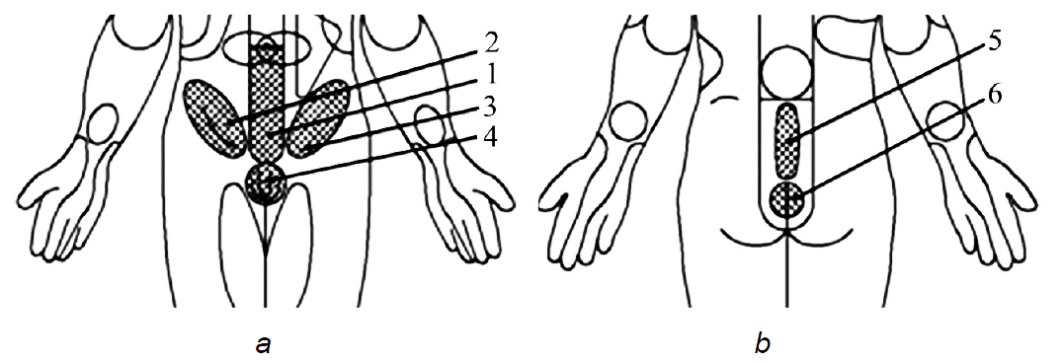
Figure 3. BAZ location for treatment and prevention of chronic prostatitis:
a – front view; b – back view

For the manufacture of men's underwear, knitted fabrics are selected (Table 1).

Table 1. Structural and physical-mechanical characteristics of knitted fabrics for making men's underwear
Designation of knitted fabric | Raw material composition,% | Thickness, mm  GOST 12023-2003 | Surface density, g/m²  DSTU EN 12127:2009 | Hygroscopicity, %  DSTU GOST 3816:2009 | Humidity, %  GOST 8845-87
Т1 | Viscose – 97 Elastane – 3 | 0.45 | 146.0 | 23.0 | 5.47
Т2 | Cotton – 100 | 0.70 | 212.4 | 17.35 | 6.61
Т3 | Cotton – 100 | 0.64 | 185.0 | 20.0 | 6.79
Т4 | Viscose – 92 Elastane – 8 | 0.65 | 188.2 | 16.0 | 3.79
Т5 | Cotton – 97  Elastane – 3 | 0.31 | 116.0 | 20.35 | 3.99

RESULTS

To select an inert knit fabric, the level of its negative, positive and inert influence on the functional state of the human body is studied (Table 2). The study was carried out for ten persons, which functional state of the body at the time of the study did not have significant deviations from the norm. Such quantity is sufficient, as definition of the functional condition of the human body with the help of HSDC «Intera-DiaCor» differs high accuracy (relative guarantee error does not exceed 5 %).

Table 2. The results of calculation of energy-information impact level of the knitted fabrics on the human body
Number of person | The level of energy-information impact of a knitted fabric sample  on the functional state of the human body:
Number of person | Negative (k_{N}) |  |  |  |  | Positive (k_{P}) |  |  |  |  | Inert (k_{І})
Number of person | Т1 | Т2 | Т3 | Т4 | Т5 | Т1 | Т2 | Т3 | Т4 | Т5 | Т1 | Т2 | Т3 | Т4 | Т5
1 | 0.06 | 0 | 0 | 0.03 | 0.02 | 0.03 | 0.07 | 0.12 | 0.03 | 0.03 | 0.91 | 0.93 | 0.88 | 0.94 | 0.95
2 | 0 | 0 | 0.02 | 0 | 0 | 0 | 0.03 | 0.02 | 0.03 | 0 | 1.00 | 0.97 | 0.96 | 0.97 | 1.00
3 | 0 | 0.02 | 0.02 | 0 | 0 | 0.08 | 0.03 | 0.02 | 0.06 | 0.02 | 0.92 | 0.95 | 0.96 | 0.94 | 0.98
4 | 0.05 | 0 | 0 | 0.05 | 0 | 0.06 | 0.05 | 0.24 | 0.06 | 0.08 | 0.89 | 0.95 | 0.76 | 0.89 | 0.92
5 | 0.06 | 0.07 | 0.12 | 0.04 | 0.05 | 0.02 | 0.07 | 0.13 | 0.02 | 0 | 0.92 | 0.86 | 0.75 | 0.94 | 0.95
6 | 0.02 | 0 | 0.02 | 0.03 | 0.04 | 0.15 | 0.09 | 0.18 | 0.12 | 0.02 | 0.83 | 0.91 | 0.80 | 0.85 | 0.94
7 | 0.03 | 0 | 0 | 0.03 | 0.03 | 0 | 0.13 | 0.04 | 0 | 0.02 | 0.97 | 0.87 | 0.96 | 0.97 | 0.95
8 | 0 | 0.03 | 0.21 | 0 | 0.02 | 0.03 | 0.02 | 0.15 | 0.04 | 0.02 | 0.97 | 0.95 | 0.64 | 0.96 | 0.96
9 | 0.02 | 0 | 0.05 | 0.03 | 0.02 | 0.03 | 0.13 | 0.05 | 0.02 | 0.02 | 0.95 | 0.87 | 0.90 | 0.95 | 0.96
10 | 0 | 0.02 | 0.03 | 0 | 0 | 0.07 | 0.20 | 0.25 | 0.13 | 0.12 | 0.93 | 0.78 | 0.72 | 0.87 | 0.88

It is established that all knitted fabrics have an energy-information impact on the human body. Considering the purpose of knitted fabrics, it is important to choose fabrics with high inertness coefficients for the functional state of the body (Table 3).

Table 3. Analysis of the investigation results of inertness level of knitted fabrics for the functional state of the human body
Coefficient value k_{І} | Percentage distribution of the number of human subjects according to inertness level of knitted fabric samples, %
Coefficient value k_{І} | Т1 | Т2 | Т3 | Т4 | Т5
0.95…1.00 | 40 | 40 | 30 | 40 | 70
0.90…0.94 | 40 | 20 | 10 | 30 | 20
0.85…0.89 | 10 | 30 | 10 | 30 | 10
0.80…0.84 | 10 | – | 10 | – | –
0.75…0.79 | – | 10 | 20 | – | –
0.70…0.74 | – | – | 10 | – | –
less 0.7 | – | – | 10 | – | –

Analysis of investigation results of inertness level of knitted fabrics made it possible to establish that a high inertness level (k_{І}=0.95...1.00) for the functional state of the body of 70 % of individuals has a pattern of knitted fabric T5. Since this fabric has the smallest thickness (0.31 mm) and a high inertness, it is selected as a lining material for manufacturing of the projected multifunctional clothing. Also high values of k_{І} have samples of knitted fabrics T4 (k_{І}=0.87...0.97) and T1 (k_{І}=0.83...1.00). This inertness level indicates that there is no excessive positive or negative energy-information effect of fabric on the state of organs and systems of the human body. That is why they are recommended as the main material for the manufacture of adaptive therapeutic and prophylactic clothing.
Analysis of research results made it possible to choose a knitted fabric T4 for the manufacture of therapeutic and prophylactic clothing. To ensure the therapeutic and prophylactic effect of the men's underwear, the distance between the centers of the silver plates is taken to be 30 mm, which makes it possible to achieve a uniform effect on the entire BAZ surface.
It is found that silver plates are intangible during adaptive multifunctional clothing operation, that is, do not cause discomfort for the consumer and do not deform during the operation of the product. This is confirmed by the results of experimental wearing of men's underwear, in which 10 people took part. Each of them used the clothing for an hour. By the beginning of the experimental wearing of the developed clothing and after its completion, the indicators of operational control are determined. Psychophysiological sensations of a person in adaptive multifunctional clothing are evaluated according to the following criteria:
– convenience in movements (seats, sit-ups, walking);
– self-estimation of the functional state of the body;
– comfort in the clothing;
– thermal sensations in the clothing.
According to the results of experimental wearing it is found that blood pressure, heart rate and self-estimation of the functional state of all persons do not deteriorate during the use of clothing. In addition, developed men's therapeutic and prophylactic underpants do not create uncomfortable sensations in motion. The persons who exploited it (100 %) note that the underwear is highly comfortable and pleasant in terms of warmth.
The effectiveness of the developed underwear is assessed by clinical approbation of medical and preventive underpants in Khmelnytsky (Ukraine) city polyclinic for ten patients, with chronic prostatitis with seasonal exacerbation in autumn. The duration of the disease lasted from five to seven years. The age of the patients ranged from twenty-one to forty-four years.
All patients underwent general clinical laboratory tests: general blood analysis with leukogram, general urine analysis, blood sugar analysis, prostate secretion analysis and ultrasound examination. In addition to the general clinical laboratory and apparatus methods, the patients underwent a study of the functional state of the body, in particular the genitourinary system, with the help of HSDC «Intera-DiaCor».
As a result of clinical examination, nine patients out of ten found a latent (subclinical) exacerbation of chronic prostatitis, which at the time of the examination was not accompanied by the manifest symptoms characteristic of this disease. One patient showed the onset of exacerbation of the disease, accompanied by clinical signs, in particular: pain, dysuric syndromes and erectile dysfunction.
All examined patients are recommended to wear the developed therapeutic and prophylactic underwear (underpants). This adaptive underwear is intended to be worn for one month for two hours a day during the period of the highest activity of the bladder channel (from 15 to 17 hours). A patient with clinical manifestations of chronic prostatitis is prescribed a course of treatment according to clinical protocols from urology, and it is recommended to wear the specified underwear according to the method described above.
In a month, all the patients underwent a control study: general clinical laboratory tests, laboratory study of the secretion of the prostate gland, examination with ultrasound and HSDC «Intera-DiaCor».
Fig. 4 shows the window of HSDC «Intera-DiaCor», which reflects the comparison of the diagnostics results of the functional state of the body without the influence of the developed multifunctional clothing and with it.

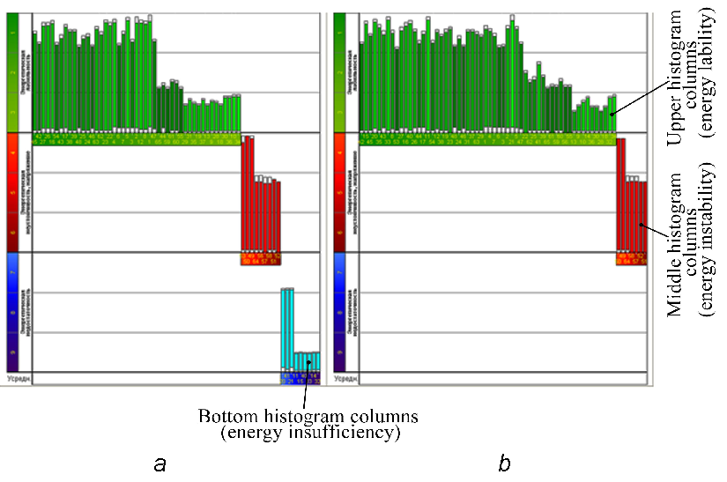
Figure 4. Windows of the software for «Intera-DiaCor» (Ukraine),
reflecting the diagnostics results of the functional state of the patient:
a – without the influence of the designed underwear;
b – with the influence of the designed underwear

Comparing the number of organs in different energy states (Fig. 4), it is established that the men’s therapeutic and prophylactic underwear has an affect the functional state of the human body.
It should be noted that none of the nine patients with a subclinical course of chronic prostatitis had a seasonal exacerbation, which was regular in previous years.
In a patient who had clinical signs of exacerbation of chronic prostatitis, the period of exacerbation decreased from fourteen days to six, and the patient's improvement was felt on the third day of complex treatment.
Thus, it is established that the use of the developed therapeutic and prophylactic underpants makes it possible to improve the functional state of the men’s body with chronic prostatitis, that is, the formed package of materials is rational, and developed multifunctional clothing is effective and adaptive.

CONCLUSIONS

Among the strengths of this research, it is necessary to highlight the development and application of the principles of multifunctional clothing conceptual design, based on the use of energy-information technologies. This allows to choosing knitted fabrics, which have a high inertness level to the functional state of the human body. This is the basis for expanding the functionality of men's underwear. In addition to the basic functions, these clothing have additional functions for treatment and prevention of chronic prostatitis.
Knitted fabrics are selected and justified, which have a high inertness level (k_{І}=0.87...0.97 and k_{І}=0.88...1.00, respectively) for the functional state of the human body, and are recommended as the basic and lining materials for the manufacture of men’s therapeutic and preventive clothing.
The effectiveness and adaptability of the developed men’s therapeutic and prophylactic underwear is estimated through clinical approbation. The improvement of the functional state of the men’s organism with chronic prostatitis after the exploitation of the developed multifunctional clothing for one month is confirmed. According to the results of multifunctional clothing experimental wearing, it is determined that for 100 % of the respondents the indicators of operational control of all patients does not deteriorate. Evaluation of the psycho-physiological sensation of a person in the developed underwear shows that adaptive multifunctional clothing is comfortable and pleasant for a warm sensation for 100 % of patients.
A positive therapeutic and prophylactic effect on patients is ensured by silver plates located on adaptive multifunctional clothing sites according to the BAZ of the lower part of the men’s body. The social effect of the work is manifested in improving the health status of men with chronic prostatitis, and, accordingly, improving the quality of their life. Provision of multi-functional clothing with advanced functionality has a positive economic effect by reducing the consumer's money costs and reducing the time spent on medical procedures.
So, the results of the work are aimed at satisfying the needs of consumers and market requirements. They also add of the opportunities for further research to provide different types of clothing of additional functionalities aimed at improving the life quality of a modern person.

REFERENCES

- About Complex. Electronic resource. Intera-DiaCor. – Available: http://www.diacor.com.ua/en/?page=complex [2019-06-29].
- Bereznenko K. P., Bereznenko S. M, Pawłowa M., Yantsalovskyі O. I., Vlasenko V. Influence of Textile Materials on the Functional State of Human Body – Assessment [Electronic resource]. Towaroznawcze Problemy Jakosci, No. 4, (2011), pp. 59–65. Available: http://bazekon.icm.edu.pl/bazekon/element/bwmeta1.element.ekon-element-000171197633 [2019-06-29].
- Bereznenko M. P., Fedotkin I. M., Bereznenko S. M., Yantsalovskyі O. Y. The physical nature of disease and the role of clothing as a factor of healthcare. Visnyk of Kherson National Technical University, No. 3, (2013), pp. 16–19.
- Kobylianska R. M, Kobylianskyi V. Ya. Monitorynh stanu imunnoi systemy ta efektyvnosti zastosuvannia informatsiinykh imunokorektoriv. Materialy naukovo-praktychnoi konferentsii z mizhnarodnoiu uchastiu «Suchasni teoretychni ta praktychni aspekty shchodo stratehii rozvytku narodnoi i netradytsiinoi medytsyny», Kyiv, 28-29 zhovtnia 2016 r., (2016), pp. 68–69.
- Lushchevska, O. M., Yantsalovskyі O. I., Peteherych S. V., Bereznenko M. P. Doslidzhennia ekolohichnoi bezpechnosti materialiv dlia vyhotovlennia verkhnoho odiahu Problemy legkoi i tekstilnoi promyshlennosti Ukrainy, No. 1 (19), (2012), pp. 105–109.
- Lushchevska, O. M, Troyan O. M., Yantsalovskyі O. I. Rozrobka metodyky doslidzhennia komfortnosti tekstylnykh materiali. Visnyk of Kherson National Technical University, No. 6, (2008), pp. 151–155.

