Information technology for quality management of engineering products
Lavrov E.A., Bahmach N.V.,
Sumy State University
Mihalevska G.I.
Khmelnitsky National University
prof_lavrov@hotmail.com, http://www.famous-scientists.ru/13333

Abstract – Development of tools for improvement the functioning of the overall production process and the technical control department, which consists of building a model of the production process, calculation the necessary performance and reliability of its operation, developing software for automation of statistical quality control and stability of the production process.
Keywords – modeling, quality control, probability, automatical control, economic efficiency, damage minimization

Introduction
One of the subsystems of the automated control system of machine building enterprise is the subsystem of quality management. As a rule, in most factories the quality problem is particularly acute in connection with the occurrence of significant percentage of defective products, as well as the complexity of the choice of economically justified measures aimed at improving quality. In most enterprises there is a Department of technical control, but the efficient organization of its activities requires precise planning with the use of qualimetry methods,mathematical analysis and statistics [1,2,3].
I. PROGRAM COMPLEX FOR TECHNICAL DEPARTMENT OF QUALITY CONTROL.

By the order of Lebedinsky plant of piston rings (Sumy region, Ukraine) it was started the work for creating informational technology for support of decision-making in quality management. Some aspects of the work described in [4,5,6]. The aim of this work is to complement [6] using the recent developments of the system and analyze the effectiveness of development.
1.1 GENERAL CHARACTERISTICS
It was developed the software system for the Department of technical quality control, which is based on an existing mathematical tools of statistical analysis of the production process, for example [6,7], which allows calculations needed to support decision making on quality.
General characteristics of the software system:
basic functions (figure 1):
• determining the likelihood of defective products;
• construction of number allocation likelihood of defective products based on the average number per unit time of marriage;
• calculation of probabilities yield products for a given statistical parameters;
• calculation of statistical unknown parameters of the known data;
• implementation of statistical analysis of a sample of product parameters, calculate the mean and variance limits of access and control, histogram graphs superimposed with probability distribution function of the density of the normal law;
• construction of control charts (X-card and S-Cards);
• calculation of risk-producer and the customer at the receiving party quality control of finished products using various combinations of the control samples and risk graph depending on percentage of defective products.

Fig.1. The main window
1.2 SUBSYSTEM «ACCEPTANCE QUALITY CONTROL»
Purpose: used to calculate the risk of the manufacturer and the customer during the final control, depending on the different parameters of the sample particles and permissible percentage of defective products.
Risk is a manufacturer in the sense of failure probabilities of receiving party products lack percentage of which is permissible. The risk of the customer is the meaning of the likelihood of unwanted party take percentage of marriage.
Figure 2 shows the main window of the subsystem. 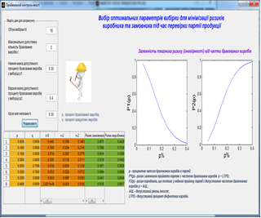
Fig.2. Main window of subsystem «Receiving quality control»
1.3 SUBSYSTEM «CONTROL FOR QUALITATIVE INDICATORS».
Purpose: construction of a number of the distribution of defective products for a certain period. We use statistics: the average number of defective products per unit of time and the maximum number of defective products for a certain period, calculated the probability that the number of defective products does not exceed a given. The main window of subsystem presented in fig.3. 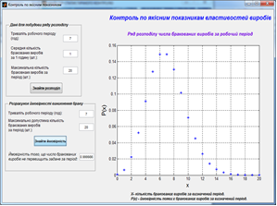Fig.3. Main window of subsystem «Control of the Quality indicators»

1.4 SUBSYSTEM «CONTROL FOR QUANTITATIVE INDICATORS».
Purpose: construction schedule probability of being the value set in parameter within a given standard deviation.
The main window of subsystem presented in figure 4.
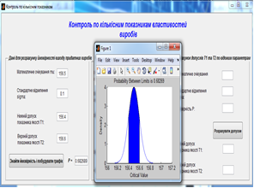

Fig.4. Main window of subsystem «Control for Quantitative indicators»

1.5 Subsystem «Statistical analysis of sample».
Purpose: statistical analysis of sample parameters, histogram superimposed on the graph of the probability distribution density of the normal law. The main window of subsystem presented in figure 5.
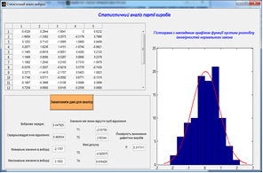
Fig.5. Main window of subsystem «Statistical analysis of the sample»

1.6 SUBSYSTEM "CONTROL CARDS".
Purpose: building control arithmetic cards (X-Card), which is applied selectively arithmetic mean of the controlled parameter, building S-Card, that contains the value of sample standard deviation..
The purpose of control charts - find abnormal changes in the data for processes that are repeated and give criteria to identify lack of statistical control. The process is statistically controlled state, if only due to random variability causes. After determining that the received variability of any deviation from it considered the result of special reasons, which should identify, eliminate or reduce their impact.
The using of the control cards and careful analysis will lead to better understanding and improvement process, minimizing losses marriage.
The problem of statistical process control - maintenance and support processes at a reasonable and stable level that guarantees the products and services specified requirements.

The main window subsystem presented in fig. 6.

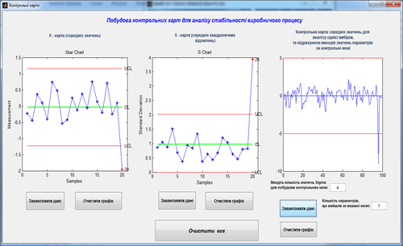

Fig.6. Main window of subsystem «Control cards»

1.7 THE SIMULATION SUBSYSTEM OF PRODUCTION PROCESSES.
For building of functional models was used the software package «Computer simulation technology of discrete human-machine interaction» [7,8], which is included as a subsystem in the software package.
The main functions are automated implementation of complex tasks of assessment, calculation of the probability of timely and error-free performance algorithms describing the production process.
The input data of the subsystem may be the results produced by the other subsystems
(see 1.2.-1.6.).
Thus it is possible to compare the probability of faults for possible production technologies.
Figure 7 presents diagrams of alternative processes of production (existing and modified).
Figures 8-9 present indicators of the quality of work execution and inspection operations (for the modified process).
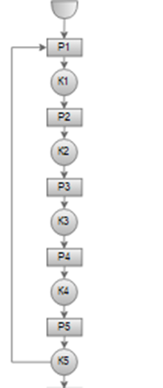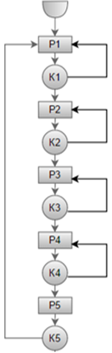
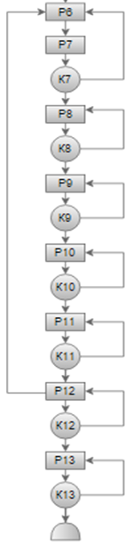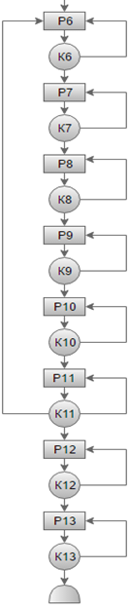
а b

Fig.7. Structure of production
determination [9],
(а – modified ,b – existing)

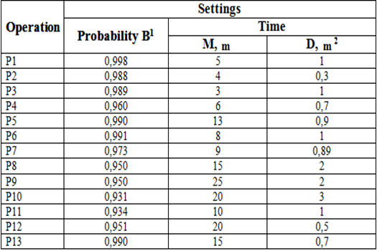
Fig.8. Quality indicators of operations performance

Fig.9. The quality indicators of control operations

Оptions:
• B1 – the probability of error-free performance;
• K00 – he probability of an error in its presence;
• K11 – probability of detecting the absence of errors in its absence;
• M – expectation runtime;
• D – dispersion runtime.
After a complete description of the functional model network, it is necessary perform the reduction (convolution) for identifying typical structures in the general algorithm and for calculating of reliability parameters of algorithm functioning.
Figure 10 shows the results of the upgraded reduction algorithm.

2. ANALYSIS OF THE EFFECTIVENESS OF THE PROPOSED TECHNOLOGY.
Figure 11 shows the result of the one of a numerical experiments, characterizing the influence of the structure of the production process in production losses.
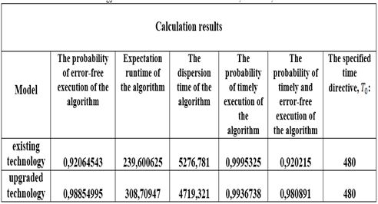

Fig.10. The results of the evaluation of alternative production methods
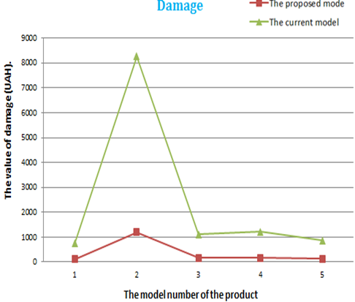

Fig.11. Comparison of possible damage when using the proposed models

CONCLUSION
The system passes test operation at Lebedinsky plant of piston rings.
Full-scale implementation of the system will solve the problem of assessment of the likelihood of violations of the process, optimize production processes, choice points, methods and techniques of control measures to ensure high quality products.
The results may be useful for engineering enterprises with discrete production.
The use of the developed information technology of quality management contributes to sound decision-making in quality management systems based on objective quantitative and qualitative indicators

REFERENCES
[1] Gubinsky A. I., Grif M. G., Tsoy E. B. About some of the optimization algorithms of the system "man-equipment" // Application of computers for optimal planning and design. – Novosibirsk: NSU, 1981, - P. 148-154.
[2] Ventzel E. S., Ovcharov D. A. probability Theory and its engineering applications. M.: Nauka, 1988.
[3] Statistical methods for quality: trans. from English. / edited by H. Kume. M.: Finance and statistics, 1990.
[4] Lavrov E.A Bahmach N.V., Krivodub A.S. The approach to modeling production and quality control of the production process production plant at Lebedinsky piston rings // Information tehnology: economy, technology, education materials,2015. Materials of the VI International Scientific Conference of Young Scientists (Kyiv, November 19-20, 2015).- Kyiv "Publisher National Agriculture University of Ukraine", 2015.- p.106
[5] Lavrov E.A., Bahmach M.V. Formalized description of the process plant at Lebedinsky piston rings for quality control problems // Computer science, mathematics, engineering “IMA” 2016 program materials and scientific and technical conference (Sumy, 18-22 April 2016) .- Amounts "Publishing SSU" 2016- p.90.
[6] Bahmach M.V., Lavrov E.A., Program complex of statistical calculations for the quality control of products at Lebedinsky plant of piston rings // Modern information technology systems and materials Fifth International Scientific Conference, AIST, 2016, с. Sumy, 25 May 2016. - The amount, type-in "SSU", 2016 - p.82.
[7] Lavrov E.A., Pasko N.B. Certificate of registration of copyright "computer program" Computer simulation technology of discrete human-machine interaction », № 45262, 21.08.2012.
[8] Lavrov E., Pasko N. Ergonomics of the of flexible systems “man-computer”// International Scientific Conference «UNITECH 10», (Gabrovo, Bulgaria, 19-20 November 2010). – Gabrovo : University Publishing House «V.APRILOV», 2010. – Vol. 1. - Р. 354-359.
[9] Gubinsky A.I. Reliability and quality of functioning ergatic systems. Leningrad: Nauka, 1982.- 270 p.

