Personnel Career Advancement Factors: Evidence from Educational Institutions

By Valentyna Litynska¹, Liudmila Romanovska², Tetiana Kravchyna³, Serhii Shandruk⁴, Olena Sopotnytska⁵, Ludmyla Kondratskа⁶

¹Marketing Department, Faculty of Economics and Management, Khmelnitsky National University, Khmelnitsky, Ukraine.
²Social Work and Pedagogics Department, Humanities Faculty, Khmelnitsky National University, Khmelnitsky, Ukraine.
³Department of Foreign Languages, International Relations and Law Faculty, Khmelnitsky National University, Khmelnitsky, Ukraine.
⁴Educational and Scientific Center for Monitoring the Quality of Education and Methodical Work, West Ukrainian National University, Ternopil, Ukraine.
⁵Department of Theoretical Foundations and Methods of Physical Education, Ternopil Volodymyr Hnatiuk National Pedagogical University, Ternopil, Ukraine.
⁶Department of Musicology and Methodology of Music Arts, Ternopil Volodymyr Hnatiuk National Pedagogical University, Ternopil, Ukraine.

ABSTRACT:
The article offers an up-to-date interpretation of the concept ‘personnel career advancement factors’. It also defines different approaches to the distribution of factors that greatly affect the career growth of personnel in educational institutions. The analysis of the factors of personnel career advancement in the educational institution is proposed to be carried out according to the developed step-by-step scheme of analysis of factors that have the greatest impact on the career advancement of employees in educational institutions. It is suggested to use cluster and discriminant analysis to establish the regularities of the relationship between these factors and to determine the relevant factors. To construct discriminant functions, the method of step-by-step inclusion is used, which involves the step-by-step addition of various combinations of factors to the calculations. As a result, a model has been developed that reflects the relationship between the factors that have the greatest impact on the career growth of employees in the educational institution. With the help of cluster analysis, the factors that influence the career growth of personnel in the educational institution are determined and, accordingly, clusters are built.

Keywords: factors, career advancement, personnel, educational institutions, discriminant analysis, cluster analysis.

1. Introduction

The individual's desire to constantly improve the professional level, which means self-improvement and maximum use of work potential, as well as the achievement of power and leadership in the team, acts as a key motivation and aspiration in the field of career growth. The strength of desire and opportunities for career advancement of personnel depend not only on individual personal qualities, but also on the existing system of career development in educational institution (Marinas et al., 2016). An individual's status and motivations in professional and personal life, as well as factors that affect his career advancement, determine the specific type of career in which he will grow professionally (Julianna, 2017; Litynska et al., 2023).
The purpose of the research is to develop scientific and methodical approaches to the determination of factors that have a noteworthy impact on the career growth of personnel in educational institutions.
To achieve the goal, the article outlines the following tasks:
– to offer an up-to-date interpretation of the concept of ‘factors of personnel career advancement’;
– to analyze different approaches to the distribution of factors that greatly affect the career growth of personnel in educational institutions;
– to develop a step-by-step scheme of analysis of factors that have the greatest influence on the career advancement of employees in educational institutions;
– with the help of discriminant and cluster analysis, to determine the factors that affect the career growth of personnel in educational institution.

2. Literature review

The analysis of scientific works of Abodunde (2018), Berezovska & Tanhel (2015), Budnyk et al. (2022), Enache et al. (2021), and Hura (2019) has led to the insight that there are different approaches to the distribution of factors that exert a significant influence on the career growth of personnel in educational institutions, accordingly, there is a need to develop effective scientific and methodological approaches to the identification and analysis of factors of career personnel in educational institutions.
This situation can also be explained by the fact that career development takes place effectively only when a person makes maximum use of internal resources and takes into account the possible influence of external factors of professional advancement to the intended goal. The internal resources of a person determine the potential of his way of activity, the implementation of which takes place in a certain environment, and any environment is a collection of many different constantly changing factors (Ilina & Buley, 2020; Karamushka, 2015; Kurchenko & Hryshchenko, 2020; Litynska et al., 2023). Accordingly, there is a need to determine those factors that have the greatest degree of influence on the career development of personnel in educational institution.
Paranytsia et al. (2022), Shylnikova & Matushkina (2019), Singh (2018), Tanhel (2015), and Tychenko (2022) pay attention to groups of factors that determine the formation of a career: factors related to a person are abilities, motivation, skills, interests, and factors related to the interaction of the personality of the surrounding people and educational institution – the influence of other people on a person's professional career.
In addition, the method of discriminant analysis can be used to classify employees according to their career performance and predict their career movement. Discriminant analysis is a statistical method that allows to determine which variables affect the division of objects into two or more classes (Lozovetska, 2019; Mera Cantos, 2023; Mishyna & Mishyn, 2014).
Cluster analysis is an effective tool for identifying patterns and grouping of factors that influence the career growth of personnel. Using the Statistica 12.0 package, in particular the ‘Cluster analysis’ module, it is advisable to conduct a hierarchical cluster analysis to group factors into clusters (Paranytsia et al., 2022).

3. Materials and Methods

The conducted research was based on the application of a number of methods. The theoretical and generalization methods were used in the analysis of the existing factors of personnel career development. To analyze these factors in detail and determine the degree of their influence on the career growth of employees, the following methods were used: observation, questionnaires, surveys and self-observation. Generalization and systematization methods were used when developing the questionnaire and for the purpose of selecting those factors that play a key role in the career growth of employees. The method of discriminant analysis was used during the construction of clusters that will allow classifying employees according to their career results and predicting their career movement. Accordingly, the method of stepwise inclusion was used to construct the discriminant functions. To determine the possible direction of career advancement of each employee, the method of substituting points for the factors included in the discriminant functions was used. In the process of determining the relationship between the factors of career growth of employees, the method of hierarchical clustering was used, namely the agglomerative method of hierarchical clustering. In addition, the Euclidean metric was used in the cluster analysis.

4. Research Results

The active development of civil society increases the role of the individual in organizing his own life and choosing ways of professional self-expression, including career formation. A career, similar to other objects, develops under the influence of various factors, direct or indirect in nature. Depending on the stage of development of society, the group of factors affecting career development changes and expands, which creates the need for their systematic analysis and research.
In the scientific literature, many interpretations of the concept of ‘career advancement factors’ can be found, but this concept should be considered through the prism of the personnel career promotion system, that is, the effective development of the components of the career promotion system ensures the rapid career development of employees.
As for the factors that have a noteworthy impact on the career growth of personnel in educational institutions, it is appropriate to note the existence of a large number of them.
One group of researchers singles out the following groups of the above-mentioned factors (Lozovetska, 2019; Mishyna & Mishyn, 2014; Tanhel, 2015):
– objective, related to scientific and technical and socio-economic conditions;
– subjective, related to the restructuring of the employee's interests, changing his orientation and actually making the decision to change the place;
– characterological, related to the stable properties of the personality, his readiness and propensity to change activities.
Some studies combine career factors into four groups (Berezovska & Tanhel, 2015; Enache et al., 2021; Hura, 2019; Shylnikova & Matushkina, 2019; Tychenko, 2022):
– socio-professional factors (general and special knowledge, qualification, industrial success, professional abilities);
– personal qualities (efficiency, work and social activity, orientation and attitudes, social and psychological properties);
– accidental (a lucky coincidence of circumstances, origin, good relations with management);
– demographic factors (gender, age, natural data).
The common to both approaches is the separation of objective factors –opportunities provided by society, and subjective factors related to the circumstances of a particular individual's life – his abilities, character traits, health, family status, etc.
In addition, there is another approach (Karamushka, 2015) to determining the influence of factors of both groups on career advancement:
1. An individual's career advancement is determined by the existing social division of labor. Therefore, a person can realize his interests, internal motivations for work only to the extent that his workforce, as well as the structure of motives and value orientations, correspond to the structure of social needs.
2. The time factor plays a specific role. The entire set of career development factors is subject to temporal changes, and different factors are dynamic to different degrees.
3. Career age limits are flexible due to differences in social living conditions and biological and psychological characteristics of individuals. As the body ages, susceptibility to new knowledge usually decreases.
4. The intensity of mobility depends on the level of qualification. Professional groups that stand high on the hierarchical gradation of workplaces, grouped by qualification criteria, are characterized by the greatest stability.
5. The primary socialization of the individual affects the career advancement of the individual. Social origin affects the labor career directly and indirectly, through the desire to give children an education. The family influences the formation and manifestation of abilities to work, the determination of the first choice of workplace. Social origin plays a significant role at the beginning of work. In the future, promotion is determined mainly by the production and social activity of the employee himself.
6. The state of the labor career or its individual elements at a certain moment depends on the state at the previous moment of time. This regularity is due to the fact that previous work experience cannot help but affect the choice of a new job.
7. Success in career advancement often creates a desire for rapid career development.
8. City dwellers – natives of the countryside have, other things being equal, less favorable conditions for a labor career than old-timers due to the limitation of their opportunities to choose places of work (Enache et al., 2021).
The specified trends of the influence of factors on the labor career also relate to the modern business career. However, in their evaluation, it is necessary to take into account changes in the content of both activities (mainly management) and the factors themselves.
In their research, a group of scientists name other factors that affect the activity: stress, pressure and uncertainty are increasingly flooding all forms of industrial life; traditional values; self-improvement and development; constant struggle for sales markets; traditional hierarchical relations.
In addition, the division of labor career factors into three levels is relevant (Kurchenko & Hryshchenko, 2020; Litynska et al., 2023):
1. The micro-level – these are factors directly related to the individual (motivation, decision-making regarding changing roles, problems of professional socialization that the employee undergoes). The micro-level factors that resist the achievement of career success are, first of all, a lack of ‘personal potential’ – a low level of motivation, indecisiveness, emotional instability and unconstructive attitudes towards achievements (risk avoidance, ‘fear of success’, failure, unrealistic goals, focus on oneself, not on the task and its result).
2. The meso-level – these are factors that are closely related to the organizational environment and individual requirements, the influence of outsiders on a person's professional growth (family planning, balancing interests with work interests, changes in management at an educational institution).
3. The macro-level – these are factors that reflect external institutional influences, such as labor market features, belonging to a national subculture, etc.
The macro-level consists of a group of three factors: social and political, which include world politics and state policy; socio-economic and social, which reflect the social policy of the state, health care, satisfactory housing conditions.
Since the purpose of this study is the development of scientific and methodological approaches to the determination of factors that have a noteworthy impact on the career growth of personnel in educational institutions, it is accordingly suggested to use a sociological survey, in particular, a questionnaire. It is recommended to use cluster and discriminant analysis, respectively, to establish the regularities of the relationship between these factors and to determine the relevant factors. Figure 1 shows a step-by-step diagram of the analysis of factors that have the greatest impact on the career advancement of employees in educational institutions.
Determination of factors that have an impact on career development (conducting a questionnaire)
Discriminant analysis of factors of career development of employees
Carrying out a cluster analysis of factors of career development of employees
Interpretation of the obtained results and division of factors into clusters
Selection of the number of clusters and their construction
Figure 1. A step-by-step scheme of the analysis of factors that have the greatest impact on the career advancement of employees
* developed by authors

Thus, one of the most effective and accessible methods of sociological research, which leads to obtaining the most objective results, is the use of questionnaires. An important advantage of questionnaires over other methods of sociological research is that during the questionnaire, the influence of the interviewer on the respondent is reduced to a minimum, which contributes to increasing the objectivity, quality and reliability of the conducted research. In this case, the use of the specified method provides an opportunity to conduct a detailed analysis of factors and determine the degree of their influence on the career growth of employees.
Formation of the list of factors that influence the career growth of personnel in educational institution and their inclusion in the questionnaire was carried out on the basis of generalization of the views of various authors and the selection of those that most often act as key moments in the career growth of employees.
The research was carried out on the basis of 32 organizations, including educational institutions of Khmelnytskyi region, namely: Khmelnytskyi National University, Khmelnytskyi Cooperative Trade and Economic Institute, Khmelnytskyi Humanitarian and Pedagogical Academy, Leonid Yuzkov Khmelnytskyi University of Management and Law, Khmelnytskyi Institute named after Blessed Volodymyr, Metropolitan of Kyiv and All Ukraine "PJSC "Interregional Academy of Personnel Management", Podilsk State University, Kamianets-Podilskyi National University named after Ivan Ohienko, Bohdan Khmelnytskyi National Academy of the State Border Service of Ukraine, Khmelnytskyi Trade and Economic College KNTEU, University of Economics and Entrepreneurship, Educational complex No. 6 of Khmelnytskyi, Khmelnytsky Secondary Comprehensive School № 24 of I-III Levels, Khmelnytskyi Specialized Comprehensive School named after Dmytro Ivakh № 27 of I-III Levels, Support Institution “Horodotsky Lyceum” № 2 of Horodotsk City Council of Khmelnytsky Region, Comprehensive school of I-III levels with Polish as language of instruction in Horodok, Khmelnytskyi region, and others.
In particular, during our study, 624 employees were interviewed, which allowed for greater accuracy of the results obtained. The large size of this sample indicates reliable and representative results of the study.
A survey of 10-30 employees was conducted in each educational institution. Respondents were asked to evaluate the impact of each factor on their career growth on a 5-point scale. The fragment of the questionnaire, according to which the employees were surveyed, is shown in Table 1.
Table 1. Fragment of the questionnaire for determining factors that have an impact on career development
№ | Questions | No | More nо, than yes | Average between yes or no | More yes, than no | Yes
№ | Questions | 1 point | 2 points | 3 points | 4 points | 5 points
1 | The positive political situation in the country affects rapid career advancement
2 | The use of an effective motivation system promotes rapid career development
3 | The level of corporate culture affects the speed of career development
4 | The higher the level of education, the better it is for a career
5 | A person's social origin affects his career growth
6 | Good family relationships have an impact on career development
7 | The longer a person's work experience, the better it is for a career
8 | The level of a person's general culture affects his rapid career advancement
Source: developed by the authors

Microsoft Office Excel programs were used to analyze the questionnaire data and process the obtained results and to determine the factors affecting the career growth of employees.
The most interesting from the perspective of analyzing the career growth of personnel in educational institutions is the question of the questionnaire, which reflects the dynamics of the employee's advancement along the career ladder during the last ten years. The answer to this question makes it possible to divide all interviewees according to career results, defining three main groups: employees who have experienced career growth; workers who mostly moved down the career ladder; employees who have remained in the same position without changes during their working career. This distribution allows for a more detailed study of the interrelationship of factors affecting each specific type of career growth of employees.
It is suggested to use the method of discriminant analysis to build clusters that will allow classifying employees according to their career results and predicting their career movement. This will provide an opportunity for the management of the organization to potentially predict the career path of the employee and determine the key factors of his career growth.
Discriminant analysis refers to the methods of pattern recognition theory and is an effective tool for multivariate statistical analysis. The main purpose of discriminant analysis is to classify it, that is, to allocate it to one of several classes in an optimal way, by measuring various characteristics of the object. The optimal way means minimizing the mathematical expectation of loss or minimizing the probability of misclassification. Within discriminant analysis, there are two general methods: standard and stepwise (the inclusion and exclusion method).
To construct discriminant functions, the method of step-by-step inclusion was used, which involves the step-by-step addition of various combinations of factors to the calculations. As a result, a model was developed that reflects the relationship between the factors that have the greatest impact on the career growth of employees in organizations (Table 2).
To determine the possible career direction of each employee, the method of substituting points for the factors included in the discriminant functions is used. Note that three directions of the employee's career movement were determined, and the maximum value among these directions indicates the most significant possible career movement of the employee.

Table 2. Discriminant models for possible career development options

№ | Possible career development option | Discriminant models
1 | Rapid career growth | Y₁ = 0,278x₁ + 0,153x₂ – 0,391x₃ + 0,218x₄ + 0,323x₅ + 0,179x₆ + 0,523x₇ – 0,316x₈ – 0,523
2 | Career unchanged | Y₂ = -0,318x₁ + 0,497x₂ – 0,158x₃ + 0,068x₄ + 1,035x₅ + 0,184x₆ + 0,007x₇ + 0,052x₈ – 0,649
3 | Career decline (failure) | Y₃ = 0,690x₁ + 0,321x₂ + 0,523x₃ – 0,287x₄ + 0,734x₅ + 1,069x₆ + 0,296x₇ – 0,187x₈ – 0,932
Y₁₋₃ – a possible career development option; х₁ – х₈ – the influence of factors on career development; х₁ – political situation; х₂ – motivation; х₃ – corporate culture; х₄ – educational level; х₅ – social background; х₆ – relations in the family; х₇ – work experience; х₈ – culture.
Source: developed by the authors

The obtained discriminant model is checked using the following criteria:
1. F-criterion (Fisher) – serves as an indicator of the significance of the approximation. The value of the F-criterion (Fisher) for this discriminant model is 22.80, which significantly exceeds its normative value (2.325). This situation indicates the importance of the obtained result.
2. Wilks' lambda – determines the quality of discrimination. The Wilks lambda indicator value for the model is 0.289, which is very close to zero, indicating high discrimination performance.
3. Squared Mahalanobis distance and posterior probability – evaluate the quality of the discriminant function. The Mahalanobis distance from the points (observations) to the center of the group and the posterior probability of employees belonging to the corresponding category is minimal, that is, it indicates the assignment of the object to the corresponding group. The employee belongs to the corresponding group with the maximum posterior probability.
According to the consolidated matrix of possible options for personnel career advancement, the quality of the constructed discriminant model is considered quite high and is 82.525% (Table 3).

Table 3. Summary matrix of possible options for personnel career advancement

A possible career development option | Rapid career growth  р = 0,52354 | Career unchanged  р = 0,42587 | Career decline (failure)  р = 0,28756 | Classification percentage
Rapid career growth | 41 | 15 | 0 | 91,043
Career unchanged | 1 | 51 | 3 | 73,856
Career decline (failure) | 0 | 0 | 16 | 82,675
Total | 42 | 66 | 19 | 82,525

So, with the help of the developed discriminant function, it is possible to assign an employee to a specific class or type of career. To determine patterns in the relationship between factors of career growth, it is suggested to use the Statistica 12.0 package, in particular its ‘Cluster Analysis’ module. The essence of cluster analysis is to combine various procedures for classification.
Therefore, using cluster analysis, it is possible to group the factors affecting the career growth of personnel in educational institution into clusters to classify them by similarity. At the initial stage of modeling, it is important to establish the main goal of the analysis, which can be defined as follows: there are n employees and their career growth assessments, which are carried out with the help of m factors. According to the results of these assessments, it is necessary to assign the factors affecting career growth to a certain i-th cluster. According to the statement of the task, the identification of clusters of factors of career growth of employees should be performed by the hierarchical method of clustering.
At the initial stage of determining the relationship between the factors of career growth of employees, it is necessary to carry out preliminary data processing, including the calculation of Spearman's rank correlation coefficients and the formation of a distance matrix. The next step is to choose the method of hierarchical clustering. Under modern conditions, the agglomerative method of hierarchical clustering is recommended to be applied. This is due to the need to consistently combine clusters, rather than dividing them.
The next stage is the selection of a measure of distance (similarity) and a classification algorithm to determine patterns of relationship between respondents and factors of career growth. In our study, the Euclidean metric was used, where the distance is calculated as follows (Paranytsia et al., 2022):
$$d\left(x_{i},x_{j}\right)= \sqrt{\sum_{t=1}^{m}{{\left(x_{it}- x_{jt}\right)}^{2}}}$$

On the basis of the obtained data, dendrograms were constructed for hierarchical agglomerative clustering of factors of career growth of employees in educational institutions.
When determining the number of clusters based on the dendrogram, it is recommended to be guided by a number of informal criteria:
– factors within the cluster must be closely related;
– factors of different clusters should have minimal interrelationships;
– under other equal conditions, the distribution of factors between clusters should be uniform;
– from the point of view of interpretation, it is optimal to divide the factors into three clusters with four factors in each.
As a criterion for assessing career growth factors, it is proposed to use the achieved level of career growth of employees.
Graphs of dendrograms (Figure 2 and Figure 3) are presented as the results of hierarchical agglomerative clustering of factors of career growth of employees by groups.
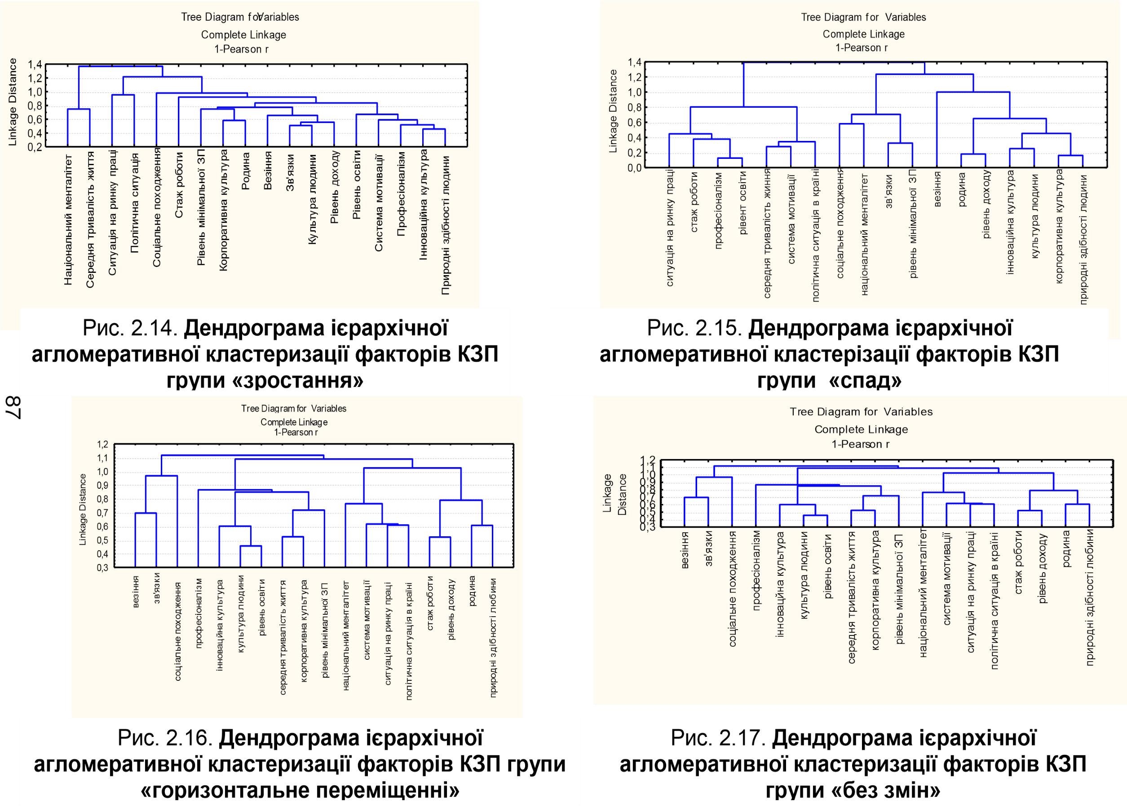

Work experience

Level of education

Professional abilities
Social background
The situation on the labor market
Personnel policy
The organizational structure
Labor team

Sex
Age
Health
Family
1
0,8
0,6
0,4
0,2

Figure 2. Dendrogram of hierarchical agglomerative clustering of factors of career growth of employees by the category ‘career decline (failure)’
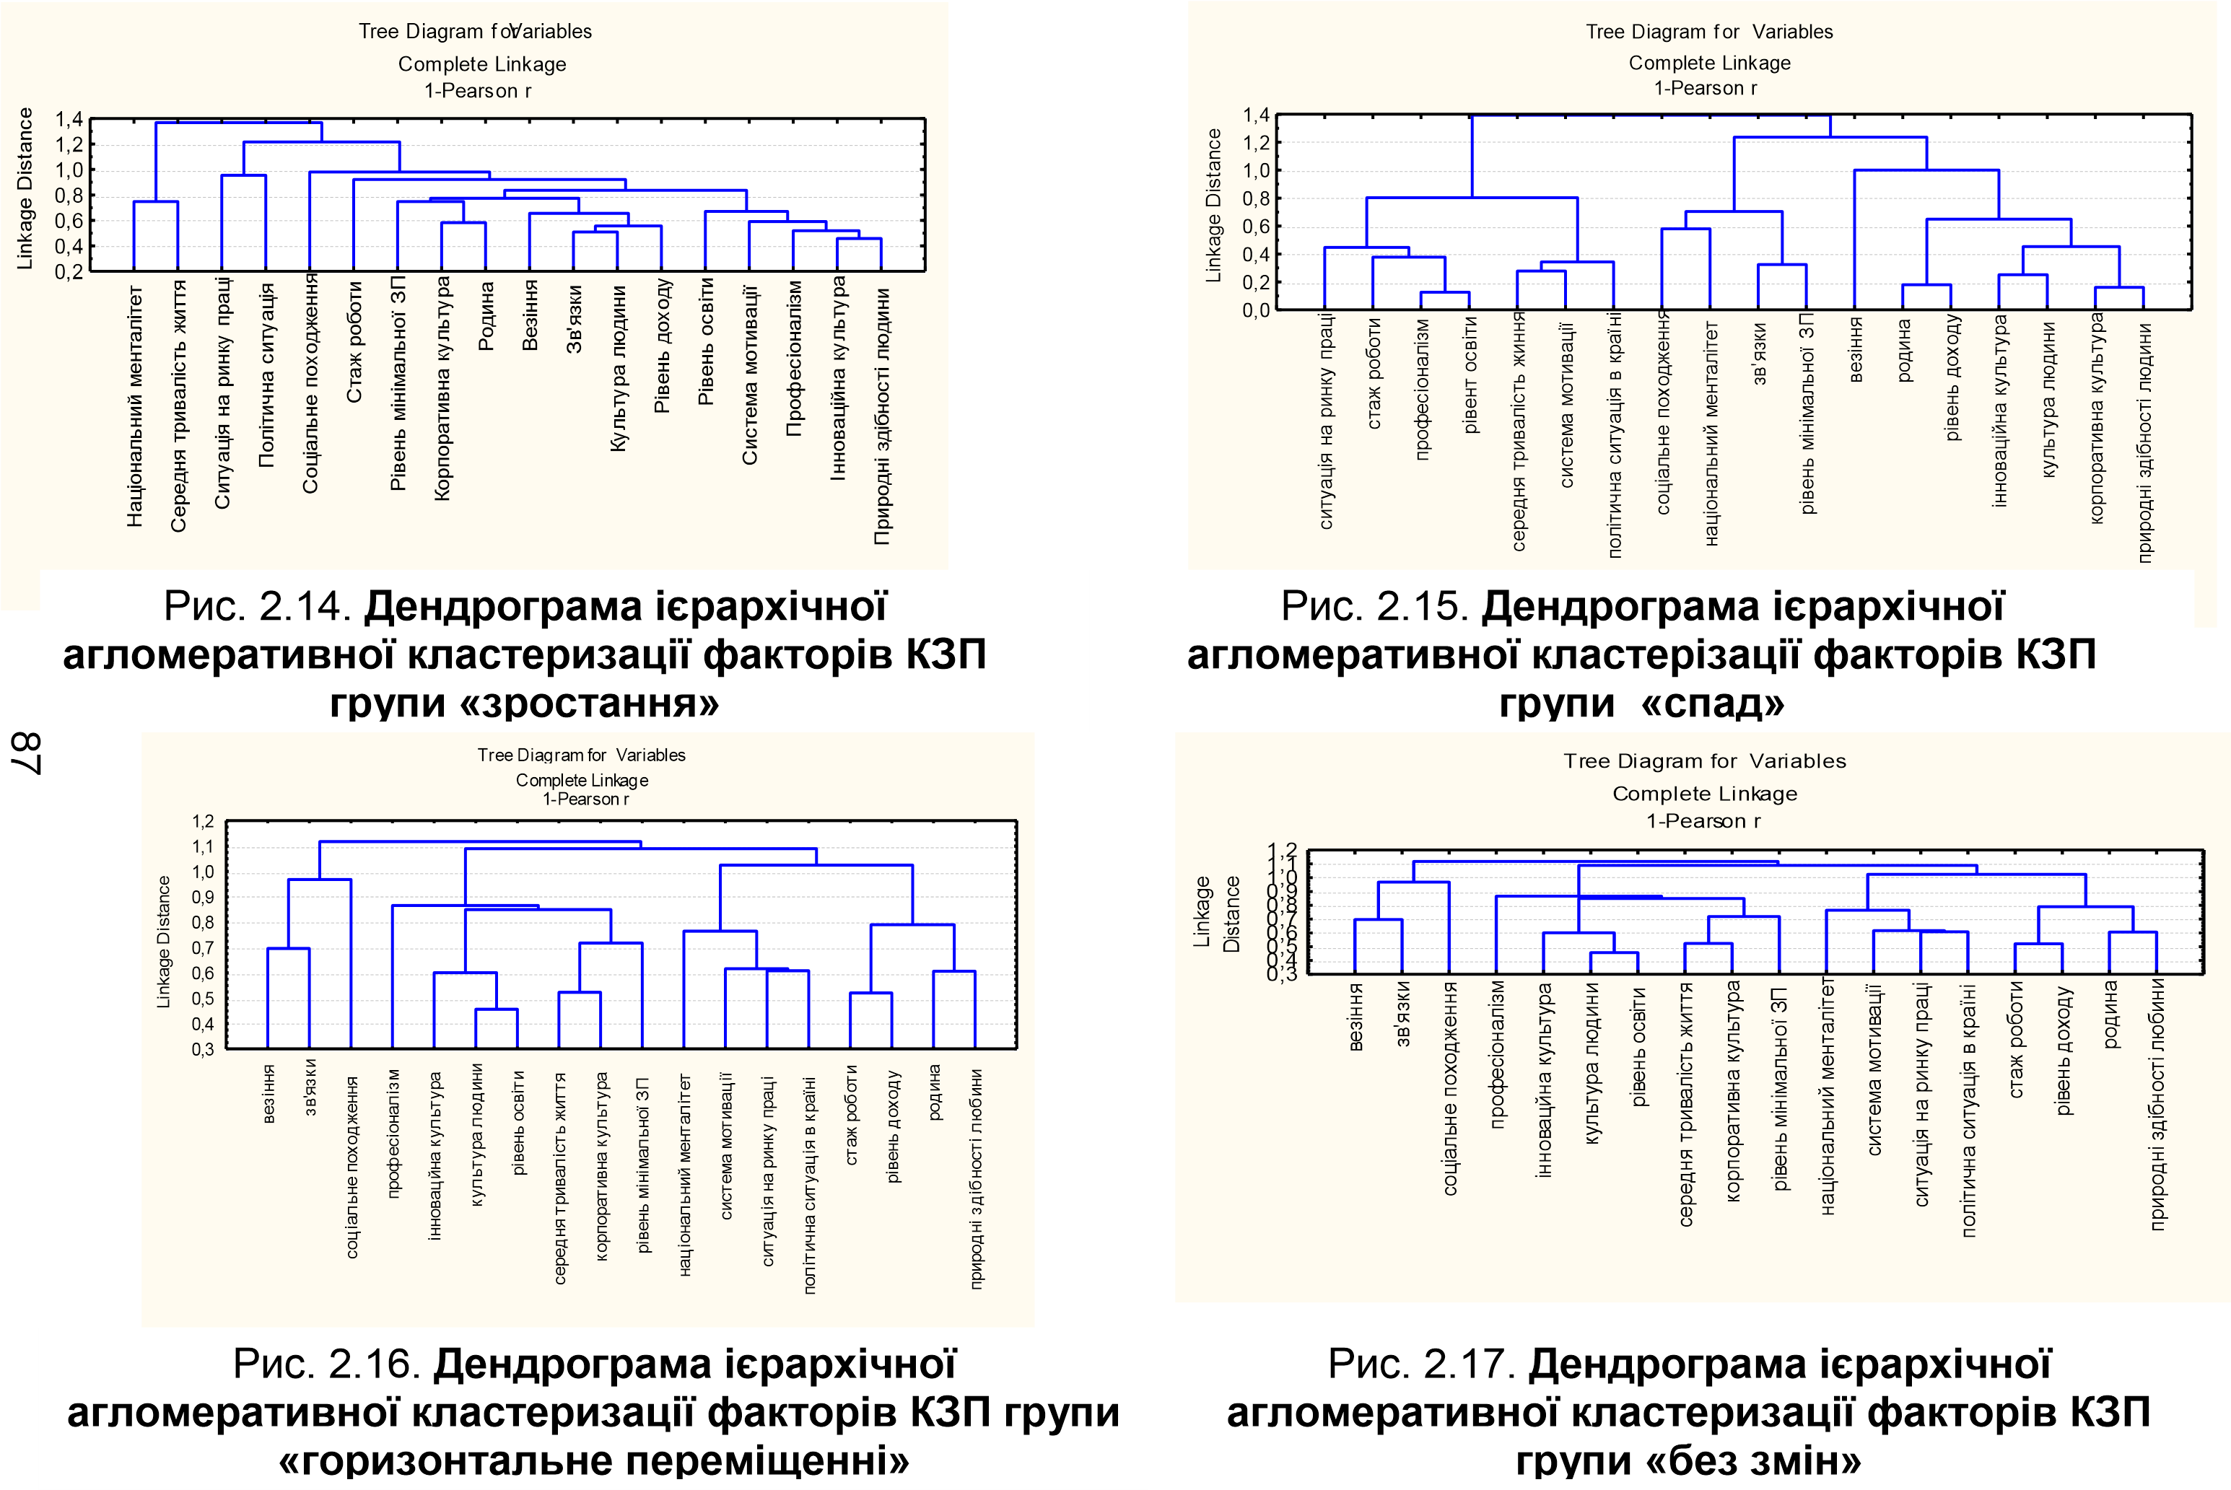
* developed by authors
A sense of duty and responsibility
Striving for leadership
Close environment
Luck
Professional abilities
Opportunity for further education
The situation on the labor market
Certification training
Relationship between health and career
Interest in learning and gaining experience
Confidence in one's own abilities
Activity in solving professional tasks
1,2
1
0,8
0,6
0,4
0,2

Figure 3. Dendrogram of hierarchical agglomerative clustering of factors of career growth of employees by the category ‘career without changes’
* developed by authors

Thus, in accordance with the specified requirements and on the basis of the constructed dendrograms, the results of hierarchical agglomerative clustering of the factors of career growth of employees were obtained, which are presented in Figures 4-5.
Cluster 1
Cluster 3
Cluster 2
Sex
Work experience
The situation on the labor market
Educational level
Professional abilities
Personnel policy of institution

Age
The organizational structure of institution
Health
Social background
Labor team
Family

Figure 4. Distribution of factors of career growth of employees into clusters of the ‘career decline (failure)’ category
* developed by authors
Cluster 1
Cluster 3
Cluster 2
Relationship between health and career
A sense of duty and responsibility
Professional abilities
Striving for leadership
Close environment
Opportunity for further education
Interest in learning and gaining experience
The situation on the labor market
Confidence in own abilities
Luck
Certification training
Activity in solving professional tasks

Figure 5. Distribution of factors of career growth of employees into clusters of the category ‘career without changes’
* developed by authors
On the basis of the above, it will be necessary to determine, due to which factors, the transition of an employee from the category of ‘unchanged career’ and ‘career decline (failure)’ to the group of ‘rapid career growth’ is possible (Fig. 6).

Figure 6. Transition of factors that affect an employee’s career advancement from the category of ‘unchanged career” and ‘career decline (failure)’ to the category of ‘rapid career growth.’
– skills and qualifications;
– achieving results;
– leadership qualities;
– strategic perception;
– communication and network of connections.
Factors of the ‘career without change’ category
Factors of ‘rapid career growth’
Factors of the ‘career decline (failure)’ category
* developed by authors

Based on the analysis of the above, it was determined that the transition of an employee from the category of ‘unchanged career’ and ‘career decline (failure)’ to the group of ‘rapid career growth’ is possible due to some factors that affect career movement. Possible reasons for this transition include:
– skills and qualifications: acquiring new skills and improving qualifications can make an employee more attractive for higher-level positions or for different departments within an educational institution;
– achieving results: an employee who achieves high results in his current role can attract the attention of management and be considered for further growth in the hierarchy;
– leadership qualities: the development of leadership qualities and the ability to manage effectively can influence the transition to higher levels of management and responsibility;
– strategic perception: understanding the strategic goals of the educational institution and the ability to make a significant contribution to their achievement can be a factor that supports the transition to categories with growth;
– communication and networking: strengthening professional relationships and networking can help an employee find new opportunities and open doors for career growth.
The results of the hierarchical agglomerative clustering mentioned above may also provide additional context and insights for understanding exactly which factors were important for workers to move from one group to another in the context of career movement.
The obtained classification of factors of career growth by types creates an opportunity for additional research by comparing the composition of clusters of each group with each other. Factors that fall into one cluster interact in the closest relationship with each other, while those that fall into different clusters have a lower degree of relationship.
Therefore, the difference in classifications of factors of various types of career growth indicates the influence of these factors, and therefore, they are decisive for the fundamental career development of personnel in the context of different directions of career movement.
Therefore, for those employees who show a greater tendency to decline along the career path, it is important that the management pays attention to such factors as professional abilities, the atmosphere in the work team, the motivation system, luck, corporate culture, work experience, etc. However, taking into account that subjective factors of the organization cannot be influenced, the most effective may be the introduction of changes in the system of motivation for career advancement of personnel.
For employees who show no change in career orientation, career development will be realized through changes in factors such as natural ability, motivation system, luck, network of connections, family, work experience, social background and average lifetime.
Given that it is almost impossible to influence the subjective factors of career growth of the management department, it is necessary to improve the personnel motivation system to bring the personnel closer to the opportunities of rapid career growth. It should be noted that the factors of career growth for employees who do not show an inclination to move in a career (that is, without changes along the career path) require the most changes, which explains the difficulty of their transition to a vertical career structure.
Therefore, the analysis of the factors of career growth of employees of organizations, carried out according to the developed scientific and methodical approach, confirms its practical significance and the validity of its implementation in the activities of organizations.

5. Discussions

In our research, we utilized selection criteria for career development factors based on prior studies and literature, as well as through conducting group discussions with various stakeholders, including educational institution employees. Reviewing previous research and literature (Berezovska & Tanhel, 2015; Enache et al., 2021; Hura, 2019; Tychenko, 2022) allowed us to consider existing knowledge and identify potentially important factors that influence career development. Group discussions, in turn, provided additional perspectives from various stakeholder groups, aiding in a comprehensive and objective consideration of this issue.
As a result of this approach, a list of factors was formed that are relevant and have the greatest impact on the career development of employees.
To prevent inaccuracies and biases, our research followed the following rules:
1) ensuring confidentiality allowed respondents to feel more comfortable and freer to express their opinions, thereby reducing the likelihood of bias or censorship in their responses;
2) the use of a scale with five answer options made it possible to obtain a wider range of answers and provide a more objective assessment, since respondents have to choose one of several possible options, which increases the variety of answers;
3) observation of respondents to confirm the obtained results made it possible to check the consistency and reliability of the obtained data by comparing the research results with real observations.
The authors of the article fully agree with the opinions of such scholars as: Kurchenko & Hryshchenko (2020); Mishyna & Mishyn (2014); Ilina & Buley (2020), concerning the fact that the
division of career factors into three levels is relevant: the micro level –these are factors directly related to the individual (motivation, decision-making regarding changing roles, problems of professional socialization that the employee undergoes); the meso-level – these are factors that are closely related to the organizational environment and the requirements of the individual, the influence of outsiders on a person's professional growth (family planning, the correlation of his interests with the interests of work, changes in management in an educational institution), and the macro-level – these are factors which reflect external institutional influences, such as features of the labor market, belonging to a national subculture, etc.
Nevertheless, the authors critically assess the views of Shylnikova & Matushkina, (2019), regarding the fact that the factors of career advancement must be divided into: objective, related to scientific-technical and socio-economic conditions; subjective, related to the restructuring of the employee's interests, changing his orientation and actually making the decision to change the place; characterological, related to the stable properties of the personality, his readiness and propensity to change activities. This is primarily due to the fact that in this case only the subjective side of the process of influence of factors on career advancement is taken into account.
At the same time, we completely concur with the viewpoint of Berezovska & Tanhel (2015); Budnyk et al. (2022); Lozovetska (2019) that it is recommended to use cluster and discriminant analyzes to establish the regularities of the relationship between career factors and to determine the relevant ones.

Conclusions
Summarizing the findings of the article, the following points can be highlighted:
1) the author's approach to the interpretation of the concept of ‘factors of personnel career advancement’ is proposed, according to which it is appropriate to consider this concept through the prism of the personnel career advancement system, that is, the effective development of the components of the career advancement system ensures the rapid career development of employees.
2) various approaches to the distribution of factors are analyzed that have a significant impact on the career growth of personnel in educational institutions;
3) a step-by-step scheme for the analysis of factors that have the greatest impact on the career advancement of employees in educational institutions has been developed, which consists of the following stages: determination of factors that have an impact on career development (conducting a questionnaire); discriminant analysis of factors of career development of employees; carrying out a cluster analysis of the factors of the career development of employees; selection of the number of clusters and their construction and interpretation of the obtained results and division of factors into clusters;
4) discriminant models were developed for possible options for career development (rapid career growth, career without changes and career decline (failure)).
5) with the help of cluster analysis, the factors that affect the career growth of personnel in educational institution are determined and the transition of factors that affect the career advancement of an employee from the category of ‘unchanged career’ and ‘career decline (failure)’ to the category "rapid career growth" is determined.
Thus, the career development of a modern individual in the conditions of a market economy has witnessed a number of problems related to professional activity, which, in turn, involves the systematic improvement of acquired knowledge and skills, the mastery of additional competencies and functions. It's crucial to develop an understanding of current trends in personal and professional growth, especially the cultivation of leadership and entrepreneurial skills in anticipation of future career opportunities. The main role in this case is played by factors that affect the career development of the employee. According to the conducted research, for those employees who show a pronounced tendency to decrease development along the career path, it is important for the management to focus on aspects such as professional skills, the atmosphere in the work team, the motivation system, the luck factor, corporate culture, work experience and others. However, taking into account that it is almost impossible to influence subjective aspects in the educational institution, the most effective is the implementation of changes in the motivation system for personnel career growth.
Considering contextual factors in career development research is relevant and necessary. The same factors can have different effects depending on the industry, type of market, cultural and social characteristics.
Conducting research in specific sectors and industries allows to reveal general trends, but also to identify those unique factors that influence career development only in certain contexts.
Examining these unique factors helps develop more accurate and effective career development strategies that meet the specific requirements and conditions of each industry. This approach contributes to a more successful and satisfied career development of employees in various industries.
For employees who do not show a desire for change in their career development, building a career path involves influencing aspects such as natural talents, motivation system, fortune, network of connections, family, work experience, social background and average life expectancy.
Considering the fact that the influence on the subjective factors of career growth is almost unattainable, it is necessary to improve the personnel motivation system to bring employees closer to opportunities for active career growth. It is important to note that the factors of career growth for those who do not show a desire for career changes (i.e., without changes in the career path) need the most changes, which explains the difficulty of their transition to a specific direction of career development.
At the same time, the perspective of further research is the need to study the factors inhibiting the career development of an employee, taking into account social and psychological representations of the individual in the context of the prevailing types of values, features of self-esteem or key determinants of the general personal qualities of the subject in career growth. In addition, the management of personnel career development, like any other process, is subject to certain forces that inhibit its development to the extent that it can cause stoppages, changes in direction and other obstacles. At certain stages of this movement, under certain conditions, a career crisis may arise, the consequences of which affect the future of both the individual and the institution.

References

Abodunde, Sola, M. (2018). Mentoring and Its Influence on Career Development of Academic Members of Selected Tertiary Institutions in Oyo State, Nigeria. Asian Research Journal of Arts & Social Sciences, 6(1), 9. https://doi.org/10.9734/ARJASS/2018/39815
Berezovska L.I., Tanhel A. (2015). Psykholohichni osoblyvosti kariery osobystosti [Psychological features of an individual's career]. Visnyk Natsionalnoho universytetu oborony Ukrainy: Zbirnyk naukovykh prats [Bulletin of the National Defense University of Ukraine: Collection of Scientific Works], 1(44), 212–217 [in Ukrainian].
Budnyk, O., Konovalchuk, I., Konovalchuk, I., Onyschuk, I., Matsuk, L., & Fomin, K. (2022). The problem of economic literacy development of children and youth. Journal of the University of Zulia, 13 (38), 235-251. https://doi.org/10.46925//rdluz.38.17
Enache, R. C., Gorghiu, G., Gorghiu, L. M., Petrescu, A.- M. A., & Stăiculescu, C. (2021). How Do the Romanian Students Consider the Research Competencies Appropriate for Their Future Career? Revista Romaneasca Pentru Educatie Multidimensionala, 13 (4), 162-179. https://doi.org/10.18662/rrem/13.4/476
Hura N.A. (2019). Zadovolenist karieroiu yak faktor kariernoho rozvytku ta sotsialno-profesiinoi mobilnosti [Career satisfaction as a factor of career development and socio-professional mobility]. Orhanizatsiina psykholohiia. Ekonomichna psykholohiia [Organizational psychology. Economic psychology], 2–3, 35–47 [in Ukrainian].
Ilina, I. & Buley, N. (2020). Career Management of Higher Education Teaching Personnel. Global Challenges and Prospects of the Modern Economic Development, 79, 714-718. https://doi.org/10.15405/epsbs.2020.03.102
Julianna, N. (2017). Career Entrants’ Expectations on Workplace Values. European Journal of Sustainable Development, 6(3), 201. https://doi.org/10.14207/ejsd.2017.v6n3p201
Karamushka, T. V. (2015). Profesiina kariera osobystosti: sutnist, osnovni vydy ta funktsii [Professional career of an individual: essence, main types and functions]. Teoretychni i prykladni problemy psykholohii [Theoretical and applied problems of psychology], 1, 181–190 [in Ukrainian].
Kurchenko, K. M., Hryshchenko, D. H. (2020). Faktory i problemy, shcho vplyvaiut na rozvytok dilovoi kariery suchasnoi osobystosti [Factors and problems affecting the development of the business career of a modern individual]. Naukovi pratsi Natsionalnoho universytetu kharchovykh tekhnolohii [Scientific works of National University of Food Technologies], 26 (3), 130–136 [in Ukrainian].
Litynska, V., Kondratska, L., Romanovska, L., Kravchyna, T., Chagovets, A., & Kalaur, S. (2023). Career Planning of Scientific-Pedagogical Personnel in Higher Education Institutions. European Journal of Sustainable Development, 12 (4), 437. https://doi.org/10.14207/ejsd.2023.v12n4p437
Lozovetska, V.T. (2019). Faktory ta problemy, shcho vplyvaiut na kariernyi rozvytok suchasnoi osobystosti [Factors and problems affecting the career development of a modern individual]. Molod i rynok [Youth and the market], 9, 44–50 [in Ukrainian].
Marinas, L. E., Igret, R. S., Marinas, C. V., & Prioteasa, E. (2016). Factors influencing career choice: the Romanian business and administration students’ experience. European Journal of Sustainable Development, 5(3), 267. https://doi.org/10.14207/ejsd.2016.v5n3p267
Mera Cantos, M. F. (2023). Didactic Program for Entrepreneurship in Students of the Initial Education Career. Journal of the University of Zulia, 14 (41), 611-624. https://doi.org/10.46925//rdluz.41.35
Mishyna, S. V., Mishyn Yu. O. (2014). Ekonomichna sutnist poniattia «kariera» [The economic essence of the concept of ‘career’]. Visnyk ekonomiky transportu i promyslovosti [Bulletin of the Economy of Transport and Industry], 47, 155–159 [in Ukrainian].
Paranytsia, N. V., Paranytsia, S. P., Bulychov, O. S. (2022). Metodolohiia modeliuvannia biznes-protsesiv [Business process modeling methodology]. Ekonomika ta derzhava [Economy and State], 3, 59–62 [in Ukrainian].
Shylnikova, Z. M., Matushkina, M. V. (2019). Upravlinnia dilovoiu karieroiu personalu orhanizatsii v suchasnykh umovakh [Management of the business career of the personnel of organizations in modern conditions]. Infrastruktura rynku [Market infrastructure], 28, 238–243 [in Ukrainian].
Singh, Sweta. (2018). Organizational career management practices, career satisfaction, and intention to quit among Indian employee: Examining the moderating effect of four types of work experience. Australian Journal of Career Development, 27, 150 – 159. https://doi.org/10.1177/1038416218768896
Tanhel, A. A. (2015). Psykholohichni osoblyvosti kariery osobystosti [Psychological features of an individual's career]. Visnyk Natsionalnoho universytetu oborot Ukrainy [Bulletin of the National University of Ukraine], 1, 212–217 [in Ukrainian].
Tychenko, M. IE. (2022). Analiz osoblyvostei profesiinoi kariery v doslidzhenniakh ukrainskykh ta zarubizhnykh naukovtsiv [Analysis of the peculiarities of the professional career in the studies of Ukrainian and foreign scientists]. Orhanizatsiina psykholohiia. Ekonomichna psykholohiia [Organizational psychology. Economic psychology], 1(25), 102–108 [in Ukrainian]. https://doi.org/10.31108/2.2022.1.25.11

