INTERNATIONAL RANKING AND CLUSTERING SYSTEMS IN COMPLEX EVALUATION OF DEMOGRAPHIC AND MIGRATION PROCESSES

D.M. Vasylkivskyi, R.S. Kvasnytska, and I.M. Lapshyn

Abstract Difficult demographic situation in Ukraine that threatens national security, especially in the socio-economic sphere, attaches great importance to the development of the concept of demographic growth and the appropriate mechanism for its implementation. The article aims to develop a methodological principles and approaches to statistical analysis of demographic indicators that determine the main factors that make significant impact on demographic situation in the regions of Ukraine and define the impact on regional international situation. To achieve it, the author has analyzed the demographic development of the country and its regions based on the method of ranging and comprehensive evaluation using the cluster analysis method. Demographic trends of migratory and natural population movement in Ukraine and its regions have been compared and classified on the basis of comprehensive evaluation of demographic situation. Statistical data demonstrated that Ukraine and its regions are characterized by sharp differences in the matter of demographics. The best demographic situation is in the West and South parts of Ukraine, the worst is in the East and North parts of Ukraine. It mainly influences natural and migratory movement of population.
Keywords Demographic situation Migration Cluster analysis Ranking

Introduction

The basis of a reasonable approach to decision-making in the demographic sphere is a systematic statistical analysis of the current demographic situation of the regions and the country, which is based on the statistical and mathematical tools of scientific research. Socio-economic infrastructure, the service sector and the specifics of production, people's living standards, labor market trends, their specifics, and the dynamics of migration processes.

_____________________
D.M. Vasylkivskyi () e-mail: vasilkivsky@gmail.com
International Economic Relations Department, Khmelnytsky National University, Khmelnytsky, Ukraine
R.S. Kvasnytska () e-mail: rstepanivna@gmail.com
Finance, Banking and Insurance Department, Khmelnytsky National University, Khmelnytsky, Ukraine
I.M. Lapshyn () e-mail: igorlaps8@gmail.com
International Economic Relations Department, Khmelnytsky National University, Khmelnytsky, Ukraine

The differentiation of demographic processes in Ukrainian regions is a consequence of historical, economic, political and other factors, which have been primarily reflected on the development of By the level of demographic development, the regions of the country were divided into three groups: regions with complex, mediated and favorable demographic situation.
The generalized reflection of the socio-economic wellfare of any country, which is shaped by both past and current social processes, is the demographic situation in this country. It is the demographic state that is one of the determining factors for ensuring a stable and secure development of the country, and optimal demographic development is a priority interest of the state, which is dualistic both as a factor and as a result of its functioning.
Thus, in the years of independence, Ukraine has experienced a demographic situation characterized by a decline in population, a rise in mortality, a decline in fertility, aging of the population and significant migration processes. These negative demographic processes occur in times of complex crisis in the domestic economy, which, in turn, contribute to the deepening and demographic crisis in the country.
The deepening of the same demographic crisis in the country today is not only one of the factors of insufficiently effective socio-economic development, but also threatens its future and national security of the state. Due to an inadequate analytical definition of the demographic situation in Ukraine, the level of realization of the priority directions of the state social policy is distorted, and the main threats to national security in this area remain unresolved.
Therefore, today the issue of improving the approaches to assessing the demographic situation is extremely relevant. After all, it is the analysis of the demographic situation in the country and its individual regions that allows negative trends forecasting and identifying problems with the qualitative composition of the population and contributes to the formation of an effective regional policy on the socio-demographic development of a particular territory.
Creation of favorable opportunities for demographic improvement and formation of preconditions for the gradual stabilization of the population and ensuring a stable tendency to improve the quality of Ukraine's demographic potential requires the study of the problematic aspects of carrying out a statistical analysis of the demographic situation in the country and in its separate regions.

Literature Review

The research of issues and problems of the demographic situation development is highlighted in the writings of many scholars. Thus, the nature, constituents and the state of the demographic situation in Ukraine are considered by such Ukrainian scientists as: N. Vlasenko, G. Gerasymenko, V. Goryovyi, E. Libanova, O. Mykolyuk, V. Novikov, S. Pyrozhkov, L. Stelmakh, O. Shekera and others. Their works give a general description of the demographic situation in the country, analyze the changes in the population structure, identify the main factors of demographic changes, describe their models, and also highlight the interrelationships. However, methodological nuances, comparative analysis using computer systems and technologies, statistical tools, with the ability to evaluate and compare the demographic situation of the regions need further development and improvement.
For today, there are few research approaches to the analysis of the demographic situation in the country based on such methods of statistical analysis as the ranking method and the clusterization method. However, it is precisely for the construction of a coherent picture of the demographic situation in the regions of Ukraine that the transition from the study of individual values of demographic indicators to their distribution and grouping is necessary in order to comprehensively assess the dynamics of the demographic situation of the regions.

The Current demographic Situation

Today, the issues of the implementation effectiveness of national social and demographic policies, programs of socio-economic development at the regional and local levels need more attention. At the same time, the primary promising goal of demographic development is the creation of favorable opportunities for demographic improvement and the formation of prerequisites for the gradual stabilization of the population and ensuring a steady trend towards improving the quality of demographic potential.
This is explained by the fact that in modern Ukraine, the demographic situation, which is determined by the structure of the population and the nature of its movement, types, types and mode of reproduction, fertility and mortality rates, the number of marriages and divorces, is characterized by great severity and intensity.
So, more than 100 years ago, demographic processes attracted the attention of specialists only, but now statistics on the demographic situation on the planet - the focus of attention of both international organizations and governments of countries and the general public. Therefore, the basis of a reasoned approach to decision-making in the demographic field is a systematic statistical analysis of the current demographic state of individual regions and the country as a whole, the results of which determine the trends and patterns of demographic processes and phenomena, assesses the inter-regional differences in demographic processes.
It should be noted that the population of Ukraine as of January 1, 2017, according to statistics, amounted to 42584.5 thousand people (excluding the temporarily occupied territory of the Autonomous Republic of Crimea and the city of Sevastopol). To provide more characteristics we will consider the main demographic indicators of the population from 2005 to 2017 in Table. 1

Table 1. Dynamics of the basic demographic indicators of the population of Ukraine

Indicators | Population,  thousand people | Number of births, people | Number of deceased, people | Natural movement of population (increase / reduce), people | Migration balance, people
2005 | 47280,8 | 426085 | 781964 | -355879 | 4583
2015 | 42928,9 | 411783 | 594795 | -183012 | 14233
2016 | 42760,5 | 397039 | 583631 | -186592 | 10620
2017 | 42584,5 | 3639897 | 574123 | -210136 | 11997
Deviation of 2017 from 2005:
Absolute | -4696,3 | -62098 | -207841 | -145743 | 7414
Relative, % | -9,93 | -14,57 | -26,58 | -40,95 | 161,77

Data table 1 indicate an annual decrease in the population of Ukraine, which in total amounted to 4696.3 thousand people (9.93%) from 2005 to 2017. At the same time, the natural movement of the population is marked by a significant excess of the number of deceased persons over the number of births, which for the analyzed period amounted to 145,743 people (40,95%).
The reduction in the population is accompanied by a virtually steady increase in the number (and, accordingly, of the share) of persons over 60 years of age. If the population census in 1959 recorded 4387.0 thousand people (10.5%), over 60 years old, and the 1970 census - 6563.8 thousand people (13.9%), then in 1979 there were 7764.8 thousand people in Ukraine ( 15.7%) more than 60 years old, in 1989 - 9256 thousand people (18%), and in 2001 - 10323 thousand people (21.4%).
The reasons for this have historical roots and accumulated over a long period of time. The First and Second World Wars, three famines (1921, 1932-1933, 1947), mass repressions of the 1930s and 1950s, the Chernobyl disaster, the protracted systemic crisis of the 1990s, had a very negative effect on the natural process of demographic evolution, led to a noticeable deformation of the age structure of the population, premature death of about 16 million people. In conjunction with a low birth rate over the past 40 years, this led to depopulation.
A correlation analysis was conducted to find a mutual relationship between economic development. A correlation index is a numerical measure of some type of correlation, meaning a statistical relationship between two variables. It assumes values in the range from −1 to +1, where +1 indicates the strongest possible agreement and −1 the strongest possible disagreement. In our case, such indicators as GDP per capita and other demographic indicators demonstrate the development of the country.
Results showed that during slow economic development, lack of stability, the population receives less financial resoucer to achieve desired way of living. That affects the birth rate, (Correlation index: 0.65), mortality rate (C.I.: -0.58) and life expectancy of the population (C.I.: 0.65). This result confirms that the economic factor strongly affects both the indicator of the average life expectancy and the demographic situation in the country in general.
Lack of stability and the decline of economy affect migration rate. The number of Ukrainian migrants is lower than in the early 1990s in general. By 2005, the number of Ukrainian migrants abroad has decreased to 6,17 million people in 2016 it has reached almost 5 million people according to the UN data.
Most of the migrants come from the west regions of the country. The main destination countries for migrant workers are Poland, the Russian Federation, the Czech Republic and Italy Ukrainian migrants make the impact on the development of above mentioned countries. Economic and demographic situation in Ukraine affects on other countries as well and influence on labour forces in European region in some cases it affects on international affeirs. Therefore the situation in Ukraine is one of international importance.
Thus, the differentiation of demographic processes in the regions is a consequence of historical, economic, political and other factors, which is primarily reflected in the degree of development of socio-economic infrastructure, the sphere of services and production specifics, people's living standards, labor market trends and their specifics, and the dynamics of migration processes. By the level of demographic development, the regions of the country are divided into three groups: regions with complex, mediated and favorable demographic situation.

Ranking analysis

Since the indicators of mechanical and natural movement of the population describe the demographic situation of the country and the region, it is expedient to use the method of comparing these indicators based on the general - integrated assessment, which is determined on the basis of statistical data characterizing the demographic situation. To build a coherent picture of the demographic situation in the regions of Ukraine, it is necessary to shift from the values ​​of demographic indicators to their distribution using the ranking method according to the nominal scale.
Thus, according to the results of the integrated assessment of the relevant indicators, the regions are assigned ranks, the comparison of which simplifies the process of comparative analysis of the demographic situation in the regions. This approach allows us to form a region's ranking based on the demographic situation based on the rankings that consist of a total score assessment.
In addition, it is possible to analyze the dynamics of the demographic situation of the regions according to their rank and rating, which results in the trends of demographic development of individual regions and the country as a whole.
Consequently, the basis for integrated assessment is the summing up of all demographic indicators for each region to the total rank, that is, to the nominal scale. Based on the analysis of the positions of scientists on the specification of the indicators characterizing the demographic situation, we consider it appropriate to carry out the distribution of demographic indicators into two groups:
- indicators, the growth of which shows the improvement of the demographic situation
(indicators-stimulants): the total fertility rate, the total marital ratio, the burden of individuals from 0-15 years, the number of women of reproductive age and the average life expectancy at birth;
- indicators, the decrease of which demonstrates the deterioration of the demographic
situation (indicators-de-stimulators): the total mortality rate, the mortality rate of children under 1 year of 1000 live births, the total divorce rate and the demographic burden of persons aged 65 and over.
Thus, according to the calculations of the first group of indicators, the demographic situation will be better in those regions where the values of the indicators will be higher. That is, the higher the value of the indicator or rank is, the better is the situation.
Conversely, according to the calculations of the second group of indicators, the demographic state will be better in those regions where the corresponding values will be lower. The calculation and analysis of the above-identified groups of demographic indicators, the formation of ranks of regions on their basis, is based on statistical data for 2005, 2016 [3] (Table 2-3).
Table 2 shows the ranks and ratings of the regions of the country, with the best indicator - there is a higher nominal value of the rank. Thus, the best demographic status in 2016 is in the Chernihiv region, which ranked first, while the last place in the ranking of 23 regions of Ukraine was taken by Rivne region.
As for the Kyiv region, in 2005 the complex assessment (rating) of the demographic indicators-stimulants was 13, in 2016 - 15. That is, there is a positive movement of the region in the ranking, with no significant impact on the increase in the fertility and marriage rate.

Table 2. Ratings and ranks of regions by the demographic indicators-stimulators group
Indicators  Regions | Total fertility rate |  | Total marriage rate |  | Demographic load by  individuals from 0-15 years |  | Number of women of reproductive age per thousand people |  | Average life expectancy  at birth |  | General Rating | Rank | General Rating | Rank
Indicators  Regions | 2005 | 2016 | 2005 | 2016 | 2005 | 2016 | 2005 | 2016 | 2005 | 2016 | 2005 | 2005 | 2016 | 2016
Vinnytska | 13 | 11 | 6 | 5 | 14 | 11 | 13 | 11 | 16 | 17 | 62 | 13 | 55 | 12
Volynska | 21 | 21 | 15 | 13 | 22 | 22 | 21 | 22 | 12 | 15 | 91 | 19 | 93 | 22
Dnipropetrovska | 8 | 9 | 20 | 7 | 4 | 8 | 7 | 10 | 4 | 2 | 43 | 9 | 36 | 6
Zhytomyrska | 19 | 17 | 11 | 7 | 17 | 18 | 18 | 15 | 1 | 1 | 66 | 15 | 58 | 13
Zakarpatska | 22 | 22 | 15 | 17 | 21 | 21 | 22 | 21 | 12 | 9 | 92 | 20 | 90 | 19
Zaporizka | 7 | 7 | 11 | 7 | 3 | 6 | 6 | 6 | 9 | 10 | 36 | 5 | 36 | 6
Ivano-Frankivska | 20 | 12 | 15 | 14 | 20 | 19 | 19 | 14 | 19 | 20 | 93 | 21 | 79 | 15
Kyivska | 12 | 19 | 21 | 22 | 8 | 16 | 12 | 18 | 9 | 4 | 62 | 13 | 79 | 15
Kirovogradska | 11 | 10 | 3 | 1 | 12 | 8 | 8 | 9 | 5 | 6 | 39 | 8 | 34 | 5
Lvivska | 17 | 13 | 8 | 19 | 16 | 15 | 16 | 16 | 21 | 21 | 78 | 17 | 84 | 17
Mykolaivska | 9 | 8 | 8 | 14 | 9 | 10 | 9 | 8 | 3 | 7 | 38 | 7 | 47 | 9
Odeska | 14 | 20 | 11 | 21 | 9 | 17 | 15 | 19 | 2 | 8 | 51 | 11 | 85 | 18
Poltavska | 3 | 6 | 6 | 5 | 6 | 4 | 3 | 4 | 11 | 12 | 29 | 3 | 31 | 3
Rivnenska | 23 | 23 | 15 | 14 | 23 | 23 | 23 | 23 | 16 | 14 | 100 | 23 | 97 | 23
Sumska | 1 | 1 | 2 | 1 | 5 | 1 | 1 | 1 | 8 | 13 | 17 | 1 | 17 | 2
Ternopilska | 15 | 5 | 15 | 7 | 18 | 13 | 16 | 7 | 22 | 22 | 86 | 18 | 54 | 11
Kharkivska | 2 | 2 | 8 | 18 | 2 | 2 | 2 | 5 | 15 | 11 | 29 | 3 | 38 | 8
Khersonska | 10 | 15 | 4 | 7 | 13 | 12 | 11 | 13 | 6 | 3 | 44 | 10 | 50 | 10
Khmelnytska | 16 | 14 | 14 | 7 | 14 | 13 | 14 | 12 | 18 | 16 | 76 | 16 | 62 | 14
Cherkaska | 5 | 4 | 4 | 4 | 11 | 5 | 4 | 2 | 12 | 18 | 36 | 5 | 33 | 4
Chernivetska | 18 | 16 | 22 | 19 | 19 | 19 | 20 | 17 | 19 | 19 | 98 | 22 | 90 | 19
Chernihivska | 6 | 3 | 1 | 1 | 6 | 3 | 5 | 3 | 6 | 5 | 24 | 2 | 15 | 1
Kyiv city | 4 | 18 | 23 | 23 | 1 | 7 | 9 | 20 | 23 | 23 | 60 | 12 | 91 | 21

By comparing comprehensive assessments, that is, the ranking of areas by the development of the demographic situation, we get three groups of regions with the corresponding rating: high, medium and low. It should be noted that the higher the rating, the better the demographic situation in the region.

Table 3. Ratings and ranks of regions by the demographic indicators-destimulators group
Indicators  Regions | Total mortality rate |  | Mortality rate of children under 1 year of age per 1000 live births |  | Total divorce rate |  | Demographic  load by  individuals aged 65 years |  | General Rating | Rank | General Rating | Rank
Indicators  Regions | 2005 | 2016 | 2005 | 2016 | 2005 | 2016 | 2005 | 2016 | 2005 | 2005 | 2016 | 2016
Vinnytska | 16 | 11 | 9 | 6 | 8 | 12 | 22 | 20 | 55 | 16 | 49 | 10
Volynska | 8 | 7 | 4 | 11 | 3 | 4 | 10 | 3 | 25 | 3 | 25 | 4
Dnipropetrovska | 15 | 18 | 11 | 15 | 23 | 22 | 13 | 14 | 62 | 18 | 69 | 20
Zhytomyrska | 18 | 16 | 10 | 13 | 8 | 7 | 17 | 15 | 53 | 15 | 51 | 12
Zakarpatska | 2 | 2 | 20 | 23 | 1 | 1 | 2 | 1 | 25 | 3 | 27 | 7
Zaporizka | 10 | 15 | 16 | 6 | 19 | 20 | 12 | 16 | 57 | 17 | 57 | 18
Ivano-Frankivska | 3 | 4 | 23 | 9 | 5 | 6 | 9 | 5 | 40 | 7 | 24 | 1
Kyivska | 17 | 17 | 1 | 1 | 13 | 23 | 14 | 10 | 45 | 11 | 51 | 12
Kirovogradska | 20 | 21 | 16 | 21 | 17 | 12 | 16 | 21 | 69 | 20 | 75 | 22
Lvivska | 4 | 6 | 4 | 9 | 2 | 2 | 7 | 7 | 17 | 2 | 24 | 1
Mykolaivska | 11 | 10 | 3 | 16 | 22 | 21 | 5 | 11 | 41 | 8 | 58 | 19
Odeska | 13 | 9 | 15 | 13 | 11 | 12 | 4 | 8 | 43 | 9 | 42 | 9
Poltavska | 21 | 22 | 6 | 4 | 19 | 10 | 20 | 19 | 66 | 19 | 55 | 16
Rivnenska | 5 | 3 | 14 | 17 | 3 | 2 | 3 | 2 | 25 | 3 | 24 | 1
Sumska | 22 | 20 | 19 | 5 | 13 | 7 | 19 | 18 | 73 | 22 | 50 | 11
Ternopilska | 7 | 8 | 8 | 2 | 6 | 5 | 15 | 11 | 36 | 6 | 26 | 6
Kharkivska | 12 | 14 | 11 | 12 | 16 | 17 | 11 | 13 | 50 | 13 | 56 | 17
Khersonska | 9 | 13 | 18 | 22 | 17 | 10 | 5 | 9 | 49 | 12 | 54 | 15
Khmelnytska | 14 | 12 | 7 | 6 | 13 | 17 | 18 | 17 | 52 | 14 | 52 | 14
Cherkaska | 19 | 19 | 11 | 18 | 19 | 12 | 21 | 22 | 70 | 21 | 71 | 21
Chernivetska | 6 | 5 | 22 | 19 | 8 | 12 | 8 | 5 | 44 | 10 | 41 | 8
Chernihivska | 23 | 23 | 21 | 20 | 7 | 9 | 23 | 23 | 74 | 23 | 75 | 22
Kyiv city | 1 | 1 | 1 | 3 | 11 | 17 | 1 | 4 | 14 | 1 | 25 | 4

Thus, in 2005, the following areas, such as: Volyn, Zakarpattya, Ivano-Frankivsk, Lviv, Rivne, Ternopil, Khmelnytsky and Chernivtsi, are among the regions with a high ranking. The low-ranking group includes the following areas: Kirovograd, Mykolayiv, Sumy, Kherson, and Chernihiv oblasts. All other areas belong to the middle group. In 2016, the high-ranking group included the following areas: Ivano-Frankivska, Lvivska, Odeska, Rivnenska, Chernivetska and Kyiv city. Among the low rating areas were Zaporizka, Kirovogradska, Mykolaivska, Poltavska, Sumska, Khersonska, Kharkivska, Cherkaska and Chernihivska. All other areas belong to the middle group. In 2005, the following situation was observed according to indicators-destimulators, with the following high-ranking groups including: Volynska, Zakarpatska, Ivano-Frankivska, Lvivska, Ternopilska, Chernivetska regions and Kyiv city. The low-ranking group includes the following areas: Dnipropetrovska, Kirovogradska, Cherkaska and Chernihivska. All other areas belong to the middle group. In 2016, the situation has almost not changed; however, the demographic situation became even worse, where it was disappointing.
Comparing the comprehensive assessments, ie the ranking of the regions with the development of the demographic situation (Figure 1), we receive three groups of regions with the corresponding ratings: high, medium and low. Note that in Figure 1, the higher the rating, the better the demographic situation. Thus, in 2005, the following areas fall into the high-ranking group: Volyn, Zakarpattia, Ivano-Frankivsk, Lviv, Rivne, Ternopil, Khmelnytsky and Chernivtsi. The regions with low ratings include Kirovograd, Mykolaiv, Sumy, Kherson and Chernihiv oblasts. All other areas belong to the middle group.
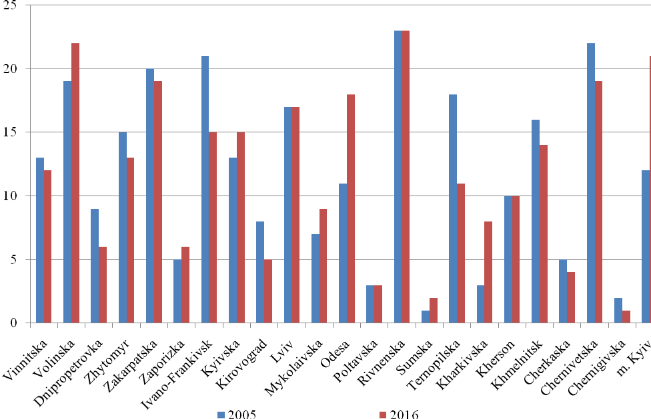
Fig. 1. The ranking of regions of Ukraine from the first group of demographic indicators (more is better)
In 2016, the high-ranking group included the following regions: Ivano-Frankivsk, Lviv, Odesa, Rivne, Chernivtsi and Kyiv. The regions with low rating include Zaporozhye, Kirovograd, Nikolaev, Poltava, Sumy, Kherson, Kharkiv, Cherkasy and Chernihiv. All other areas belong to the middle group.
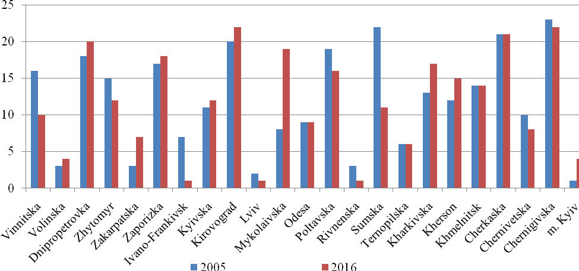
Fig. 2. The rating of regions of Ukraine for the second group of demographic indicators (less is better)
As for the indicators of the second group (Figure 2), in 2005 the following situation was observed, the following areas were included in the high-ranking group: Volyn, Zakarpattia, Ivano-Frankivsk, Lviv, Ternopil, Chernivtsi regions and Kyiv. The regions with low ratings include Dnipropetrovsk, Kirovograd, Cherkasy and Chernihiv. All other areas belong to the middle group. In 2016, the situation was almost unchanged, mainly where, often, the demographic situation was disappointing, it became even worse.
Thus, the most depressed region from the demographic point of view is the North and East of the country, preceding almost all criteria of the West, and partly the South of the country. Since 2005, the situation didn't changed dramatically, in general no significant changes took a place. However, these changes become apparent if they are viewed within specific indicators and areas. In general, the situation in the country has not become better and remains disappointing.

Cluster analysis
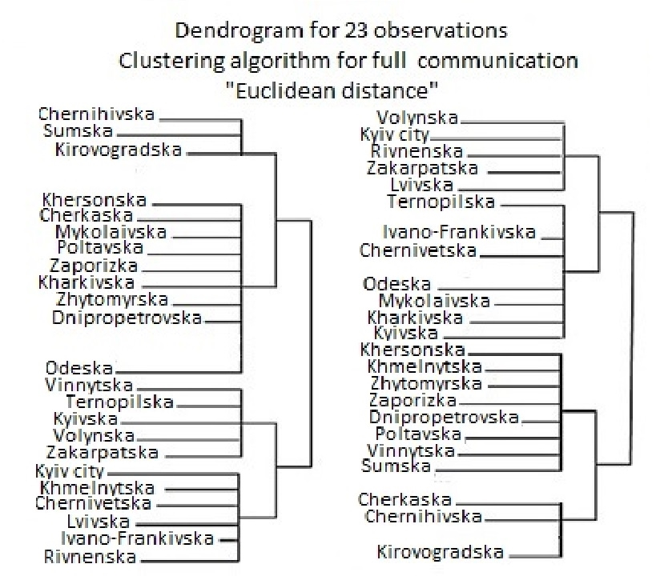
Fig. 3. Results of cluster analysis in two groups of demographic indicators

On the basis of the algorithm for full-connection, we have built a dendrogram for 23 observations (regions), figure 3 reflects the clusterization of the regions of Ukraine by the total rating of their indicators-stimulators and indicators-destimulators. Thus, by indicators-stimulators, all regions were ranked in four clusters. Below the left side there are areas characterized by the highest demographic status – 1-th cluster (5 oblasts and the city of Kyiv). The 2-nd cluster includes five oblasts and is characterized by a higher average demographic development. The situation in 3-rd cluster, which includes eight regions, is worse. The worst demographic situation is in 4-th clusters, which includes three oblasts.
It is clear from the left side of the figure that the East, North and South-East of the country are depressed. In the West and the Northwest the situation is better. According to the indicators-destimulator, the dendrogram of cluster analysis also consists of 4-th clusters (four oblasts and the city of Kyiv), which are characterized by the highest demographic state located on top of the right-hand side of the figure and belong to 1-st cluster. Accordingly, the bottom 3 areas are composed of four clusters, which are characterized by the worst demographic situation. 2-nd and 3-rd clusters contain, respectively, eight and seven regions. The situation in these clusters is mediocre.

Conclusion

The overall demographic and economic situation in Ukraine is constantly getting worse. Migration processes have been affected by negative consequences of economic development. Labor forces in the form of migrants are looking for ways to better coditions of living, so the young population migrates to neighboring countries and contributes to their development at a time when this is not happening in Ukraine.
In general, Ukraine and its regions have been characterized by a sharp difference in demographic indicators. As already mentioned, the best demographic situation in the West and the South is worse in the East and North. The demographic and economic problems in Ukraine influence on other countries and in general on a region by the migrants.
The use of ranking analysis allowed obtaining detailed understanding of the situation of what is happening in Ukraine. The use of the ranking and cluster analysis method for grouping the regions of the country into two groups of demographic indicators show almost identical results to those obtained by grouping the regions by rank and ratings derived from comprehensive estimates of the demographic situation in the country.
This fact suggests that the use of these methods is expedient and can be used to carry out a comprehensive assessment of the demographic situation in the country. However, the methods and methodology for the application of such statistical methods of analysis requires further improvement of their practical application.

References
Novikov, V. M. (2004). Social infrastructure as a factor in preserving the demographic potential
of Ukraine. Demography and Social Economy
Mykolyuk O. (2011). Are people in Ukraine the main value? About positive trends in the
demography of Ukraine, which have already positive tendencies recorded by the statistics
and how the state is preparing for the population census. “Den” Newspaper. Available at:
https://day.kyiv.ua/uk
Statistical Information "Population and Migration" for 2005-2016 (2017). Available at:
http://www.ukrstat.gov.ua/
Shekera O. H. Demographic situation in the world and in Ukraine. Available at:
http://healthysociety.com.ua/index.php?option=com_content&view=article&id=121:2011-07-03-09-43-30&catid=36:2011-04-19-08-30-45&Itemid=58
UN data base migration statistics. Available at:
http://www.un.org/en/development/desa/population/migration/data/estimates2/estimates17.shtml
Pyrozhkov S. I. (2004). The demographic factor in the global development strategy of Ukraine. Demografija ta social'na ekonomika, (Demography and social economy), 2004-1-2, 5-21 (in Ukr.)
State statistics service of Ukraine, population of Ukraine 2010, Demographic Yearbook, Kyiv 2011. Available at: http://database.ukrcensus.gov.ua/PXWEB2007/ukr/publ_new1/2011/publ2011.asp
State statistics service of Ukraine, population of Ukraine 2014, Demographic Yearbook, Kyiv 2015. Available at: http://database.ukrcensus.gov.ua/PXWEB2007/ukr/publ_new1/2015/naselen_2014pdf.pdf
State statistics service of Ukraine. Metadata. Available at: http://database.ukrcensus.gov.ua/MULT/Dialog/statfile_c.asp
The World Bank (2015). Population in Ukraine. Available at: http://data.worldbank.org/indicator/SP.POP.TOTL?locations=UA
Central Intelligence Agency (2016). The World Factbook, Ukraine. Available at: https://www.cia.gov/library/publications/the-world-factbook/geos/up.html

